University of California at Santa Barbara
Physics Department

The LT Bad Run, Bad Data Detection Program
by Jingtian Yu

1. Purpose
From numerous runs in long-term thermal cycles, we have seen a few modules’ data that have obvious running errors by comparing to the testing data from ARCs. These running errors usually are the results of the lost of voltage/current, high noise slots, module defects, or other factors. The purpose of this detection program is to analyze specific variables, channel flags and catches bad runs without having to go through xml files and plots manually.

2. Testing Procedure
The main program, lt.pl is written in Perl with a sub script, relay.pl, and an attached file, query.txt. All three files need to be in the same directory as the LT xml files. To run the analysis, type:
perl lt.pl <xml file>
And then, just sit and wait for the results.
The entire procedure is divided into four tests: Average Common Mode Noise Test, Average Noise Test, Average Peak Time Test, and Channel Flag Test.
The first three tests are executed over all three sets of data from LT. (First, Cold, Last)

2.1 Average Common Mode Noise Test (Avg. CMN Test)
By examining several known bad runs, we find that the most common variable that correlates with a bad run is the Avg. CMN. For instance, an unbiased module would mostly likely create a high value of Avg. CMN.
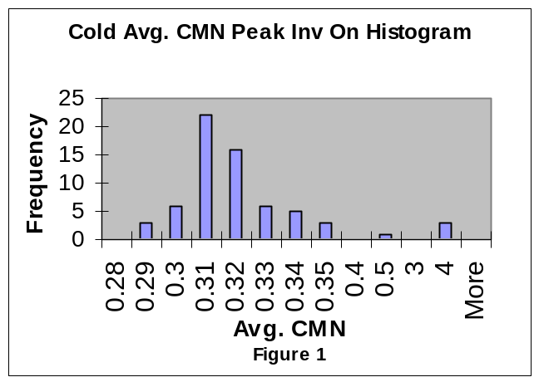By using LT data from ninety-four qualification modules, we created histograms for Avg. CMN in all four modes (Peak Inverter On, Peak Inverter Off, Deconvolution Inverter On, Deconvolution Inverter Off) in all thee stages of the thermal cycle (First, Cold, Last). That’s a total of twelve Avg. CMN variables.
Then by looking at the histogram like the one in Figure 1, we determine a set of high and low cut values within the confine of a normal distribution. Here, a reasonable cut value for Cold Avg. CMN Peak Inv On is <0.28, 0.4>.
The Avg. CMN Test extracts actually Avg. CMN data out of a LT xml file and compares it to the cut values presets. If the data goes outside of the boundaries of the cut values, it is then marked as a bad value. For each thermal cycle stage, if there’s one bad value out of all four modes, the data will fail the test and be marked as a bad run.

2.2 Average Noise Test (Avg. Noise Test)
The Avg. Noise Test does essentially the same as the Avg. CMN Test. It compares the actual data to a set of cut values that were determined by the qualification module histograms. It marks the data as a bad run, if there is a bad Avg. Noise value.
However, because of the nature of Avg. Noise, bad values have less obvious deviation from the normal cut value. Thus the detection result is less reliable than Avg. CMN Test. It is used in case the Avg. CMN Test fails to catch a certain type of bad run.

2.3 Average Peak Time Test (Avg. Peak Time Test)
Just like the first two tests, this test has the same concept and algorithm, and a set of its own cut values. It is used to catch more uncommon bad runs, such as a high voltage lost.
(See Appendix B for all the variables and their histograms and cut values)

2.4 Channel Flag Test
In either ARCs or LT data, there is a set of data called the bad channel flag field. This field consists of pairs of channel number and flag code, for instance, <045 16>. It means channel 045 is flagged as a bad channel because it has a “16” problem. Here, “16” is a code for a specific problem. The standard codes for the flags are:
2: 2SO (pa-sensor open)
4: likely 2SO
8: 1SO (sensor-sensor open)
16: likely 1SO
32: unknown open
64: high noise
128: short
256: low leak pinhole
512: high leak pinhole
1024: unknown
Sometimes other number might appear like <357 10>. Here, “10” is an “or” combination of the flags in all four modes. And to understand it, keep subtracting the highest power of 2 that’s lower than the previous difference. 10=8+2. Thus channel 357 was flagged as a 2SO in some modes and 1SO in the other modes.
The Channel Flag Test uses relay.pl and query.txt to extract the bad channel flag field from the ARCs database and then compares it with each of the LT bad channel flag fields (First, Cold, Last).
There are five possible scenarios that the flag field from ARCs can be matched with the flag field from LT.
The first two are the positive scenarios.
An exact matching requires a bad channel be found in both flag fields, and the channel has to be flagged the same in both flag fields. <036 64> in ARCs, <036 64> in LT.
An open matching is less strict than an exact matching. But it is only within the confines of opens (flag code lower than 64). If a bad channel is found in both field and is marked as a type open, then there are several ways it can pass the test.
If a channel is flagged as 1SO (8) in one field and likely 1SO (16) in the other field, it is consider a passing match. If a channel is flagged as a 2SO (2) in one field and likely 2SO (4) in the other field, it is a passing match. It should be noted that the “or” combination of the above matching are also passing matches. It means a channel with “6” (4+2) flag in one field, and “4” flag in the other field, it is a passing match. <043 24> and <043 16> is a passing match.
If a channel is flagged as unknown open (32) in one field and any types of open (any flag code lower than 64, exact flag or “or” combinations) in the other field, it is consider a passing match.
Here are the three negative scenarios.
An un-matched channel is when a bad channel can only be found in one of the flag field, either ARCs, or LT, but not the other.
A mis-matched channel is when a channel is found in both flag fields, but it is flagged differently and one of the flag is non-open (flag code higher than 63). That means <005 128> and <005 32> is a failing match. <005 128> and <005 256> is also a failing match.
An open confusion is when a channel is flagged as 2SO type (2, 4, 6) in one field, and 1SO type (8, 16, 24) in the other field. It is a failing match.
The three failing matches weigh differently in determining whether the data is a bad run or not. A mis-matched channel or an open confusion is counted as 0.5 false flag, which is less severe than an un-matched channel, which is counted as 1 false flag.
If a channel fails the matching in more than one LT flag field (First, Cold, Last), then the worst failing match is counted for false flag. That means if a channel fails as an open confusion between ARCs and LT First, fails as a mis-matched channel between ARCs and LT Cold, and fails as an un-matched channel between ARCs and LT Last. The failing match between ARCs and LT Last is then taken and counted as a false flag. (Note: a mis-matched channel is worse than an open confusion.)
The current setting for passing the Channel Flag Test is to have less than four false flags.

3. Output of the Program
The output of the program gives you all the tested variables and what is a good value and what is not. (See Appendix A for samples of a good run and a bad run)
A xml file comes from a good run overall, if it passes all of the tests in all three stages, and it comes from a bad run if it fails one of the test.

4.Problems and Limitations
The algorithm for Avg. CMN, Avg. Noise, in First and Last is exactly like the one in Cold. However, these noise variables react much less violently in a bad run during First and Last stage. Thus the Cold Test would distinguish a bad run much easier. Hopefully it will be improved by observing more data and adjusting the cuts and algorithm accordingly.
Because of the difference in each slots, modules, and testing environment the cuts for Avg. CMN, Avg. Noise, Avg Peak Time might need adjustment depend on the testing ground.
Because of non-exact nature of the LT flagging, we had to use a loose match system for open channels, which can be a potential hole for bad runs to pass. However, the ARCs and LT program are being improved from time to time. And, this algorithm for matching will change accordingly.

5.Future Development
In the future, the Bad Run Detection Program will be able to handle a group of xml files at once as suppose to just one xml file, and possibly with additions of more details and more accurate algorithm. It probably will be integrated into Defect Analyzer and become a fully automatic process.

Appendix A
Detection Program output:
-Here’s what a typical good run looks like:

Analyzing xml file 5202.xml ...

Module#: 30200020005202

First Test--------
Avg. CMN Peak Inv On: <0.267> good
Avg. CMN Peak Inv Off: <0.295> good
Avg. CMN Dec Inv On: <0.433> good
Avg. CMN Dec Inv Off: <0.480> good
Good Run by Avg. CMN Test in First

Avg. Noise Peak Inv On: <1.526> good
Avg. Noise Peak Inv Off: <1.518> good
Avg. Noise Dec Inv On: <1.927> good
Avg. Noise Dec Inv Off: <1.858> good
Good Run by Avg. Noise Test in First

Avg. Peak Time Peak Inv On: <65.2> good
Avg. Peak Time Peak Inv Off: <67.0> good
Avg. Peak Time Dec Inv On: <32.9> good
Avg. Peak Time Dec Inv Off: <33.2> good
Good Run by Avg. Peak Time Test in First

Cold Test-------
Avg. CMN Peak Inv On: <0.279> good
Avg. CMN Peak Inv Off: <0.305> good
Avg. CMN Dec Inv On: <0.471> good
Avg. CMN Dec Inv Off: <0.478> good
Good Run by Avg. CMN Test in Cold

Avg. Noise Peak Inv On: <1.475> good
Avg. Noise Peak Inv Off: <1.478> good
Avg. Noise Dec Inv On: <2.095> good
Avg. Noise Dec Inv Off: <2.049> good
Good Run by Avg. Noise Test in Cold

Avg. Peak Time Peak Inv On: <57.2> good
Avg. Peak Time Peak Inv Off: <61.5> good
Avg. Peak Time Dec Inv On: <28.2> good
Avg. Peak Time Dec Inv Off: <29.7> good
Good Run by Avg. Peak Time Test in Cold

Last Test-------
Avg. CMN Peak Inv On: <0.270> good
Avg. CMN Peak Inv Off: <0.290> good
Avg. CMN Dec Inv On: <0.421> good
AVg. CMN Dec Inv Off: <0.476> good
Good Run by Avg. CMN Test in Last

Avg. Noise Peak Inv On: <1.529> good
Avg. Noise Peak Inv Off: <1.516> good
Avg. Noise Dec Inv On: <1.926> good
Avg. Noise Dec Inv Off: <1.856> good
Good Run by Avg. Noise Test in Last

Avg. Peak Time Peak Inv On: <65.0> good
Avg. Peak Time Peak Inv Off: <67.0> good
Avg. Peak Time Dec Inv On: <32.9> good
Avg. Peak Time Dec Inv Off: <33.2> good
Good Run by Avg. Peak Time Test in Last

--------------------------------
ARCs Channel Flags: <99 8 243 2 362 8 363 8 364 8 750 2 751 2 752 2 753 2>
XML Channel Flags:
First: <99 16 243 6 362 16 363 128 364 128 750 6 751 6 752 6 753 6>
Cold: <99 16 243 6 362 16 363 128 364 128 750 6 751 6 752 4 753 6>
Last: <99 16 243 6 362 16 363 128 364 128 750 6 751 6 752 6 753 6>
First: Ch <99 1SO> confirmed
Cold: Ch <99 1SO> confirmed
Last: Ch <99 1SO> confirmed
First: Ch <243 2SO> confirmed
Cold: Ch <243 2SO> confirmed
Last: Ch <243 2SO> confirmed
First: Ch <362 1SO> confirmed
Cold: Ch <362 1SO> confirmed
Last: Ch <362 1SO> confirmed
First: Ch <363> was flagged <1SO> in ARCs, but <short> in LT
Cold: Ch <363> was flagged <1SO> in ARCs, but <short> in LT
Last: Ch <363> was flagged <1SO> in ARCs, but <short> in LT
First: Ch <364> was flagged <1SO> in ARCs, but <short> in LT
Cold: Ch <364> was flagged <1SO> in ARCs, but <short> in LT
Last: Ch <364> was flagged <1SO> in ARCs, but <short> in LT
First: Ch <750 2SO> confirmed
Cold: Ch <750 2SO> confirmed
Last: Ch <750 2SO> confirmed
First: Ch <751 2SO> confirmed
Cold: Ch <751 2SO> confirmed
Last: Ch <751 2SO> confirmed
First: Ch <752 2SO> confirmed
Cold: Ch <752 2SO> confirmed
Last: Ch <752 2SO> confirmed
First: Ch <753 2SO> confirmed
Cold: Ch <753 2SO> confirmed
Last: Ch <753 2SO> confirmed
Total number of channels that didn't flag in LT: 0
Total number of extra channel flags in LT: 0
Total number of channels with 1SO, 2SO confusion: 0
Total number of channels with mis-matched flags: 2
Good Run by Channel Flag Test

GOOD RUN BY ALL TESTS: 5202.xml

-Here’s what a bad run looks like:

Analyzing xml file 5379.xml ...

Module#: 30200020005379

First Test--------
Avg. CMN Peak Inv On: <2.663> bad
Avg. CMN Peak Inv Off: <0.321> good
Avg. CMN Dec Inv On: <0.478> good
Avg. CMN Dec Inv Off: <0.470> good
Bad Run: un-common Avg. CMN in First

Avg. Noise Peak Inv On: <1.495> good
Avg. Noise Peak Inv Off: <1.597> good
Avg. Noise Dec Inv On: <2.091> good
Avg. Noise Dec Inv Off: <2.011> good
Good Run by Avg. Noise Test in First

Avg. Peak Time Peak Inv On: <66.2> good
Avg. Peak Time Peak Inv Off: <64.5> good
Avg. Peak Time Dec Inv On: <32.5> good
Avg. Peak Time Dec Inv Off: <32.2> good
Good Run by Avg. Peak Time Test in First

Cold Test-------
Avg. CMN Peak Inv On: <3.415> bad
Avg. CMN Peak Inv Off: <N/A> bad
Avg. CMN Dec Inv On: <0.368> bad
Avg. CMN Dec Inv Off: <0.431> bad
Bad Run: un-common Avg. CMN in Cold

Avg. Noise Peak Inv On: <1.806> bad
Avg. Noise Peak Inv Off: <N/A> bad
Avg. Noise Dec Inv On: <1.830> bad
Avg. Noise Dec Inv Off: <2.110> good
Bad Run: un-common Avg. Noise in Cold

Avg. Peak Time Peak Inv On: <N/A> bad
Avg. Peak Time Peak Inv Off: <64.9> bad
Avg. Peak Time Dec Inv On: <46.7> bad
Avg. Peak Time Dec Inv Off: <28.1> good
Bad Run: un-common Avg. Peak Time in Cold

Last Test-------
Avg. CMN Peak Inv On: <0.308> good
Avg. CMN Peak Inv Off: <0.319> good
Avg. CMN Dec Inv On: <0.454> good
AVg. CMN Dec Inv Off: <0.473> good
Good Run by Avg. CMN Test in Last

Avg. Noise Peak Inv On: <1.612> good
Avg. Noise Peak Inv Off: <1.600> good
Avg. Noise Dec Inv On: <2.092> good
Avg. Noise Dec Inv Off: <2.009> good
Good Run by Avg. Noise Test in Last

Avg. Peak Time Peak Inv On: <61.3> good
Avg. Peak Time Peak Inv Off: <63.8> good
Avg. Peak Time Dec Inv On: <32.0> good
Avg. Peak Time Dec Inv Off: <32.1> good
Good Run by Avg. Peak Time Test in Last

--------------------------------
ARCs Channel Flags: <1 1024 2 64 3 64 4 64 5 64 6 64 344 32 768 1024>
XML Channel Flags:
First: <1 1024 ……………….768 32> (Extremely long string, abbreviated)
Cold: <1 1040……………….768 1024>
Last: <344 6 717 64 718 64 719 64 753 64 754 64>
Fisrt: Bad data, at least 494 extra false flags in LT!
Cold: Bad data, at least 751 extra false flags in LT!
Last: Ch <1> was not flagged in LT
Last: Ch <2> was not flagged in LT
Last: Ch <3> was not flagged in LT
Last: Ch <4> was not flagged in LT
Last: Ch <5> was not flagged in LT
Last: Ch <6> was not flagged in LT
Last: Ch <344 open> confirmed with <344 2SO>
Last: Ch <768> was not flagged in LT
Total number of channels that didn't flag in LT: 8
Total number of extra channel flags in LT: 759
Total number of channels with 1SO, 2SO confusion: 0
Total number of channels with mis-matched flags: 0
Bad Run: too many Un-matched/Mis-matched Channel Flags

BAD RUN OVERALL because of failing: <First Avg. CMN Test> <Cold Avg. CMN Test> <Cold Avg. Noise Test> <Cold Avg. Peak Time Test> <Channel Flag Test>
5379.xml

Appendix B

Variables in First and their cut values:
Avg. CMN Peak Inv On: <0.24 0.363>
Avg. CMN Peak Inv Off: <0.275 0.403>
Avg. CMN Dec Inv On: <0.41 0.55>
Avg. CMN Dec Inv Off: <0.443 0.76>
Avg. Noise Peak Inv On: <1.366 1.626>
Avg. Noise Peak Inv Off: <1.345 1.7>
Avg. Noise Dec Inv On: <1.754 2.186>
Avg. Noise Dec Inv Off: <1.688 2.102>
Avg. Peak Time Peak Inv On: <56.7 67.2>
Avg. Peak Time Peak Inv Off: <60.1 69.2>
Avg. Peak Time Dec Inv On: <29.5 34.7>
Avg. Peak Time Dec Inv Off: <29.8 35>

Variables in Cold and their cut values:
Avg. CMN Peak Inv On: <0.27 0.35>
Avg. CMN Peak Inv Off: <0.28 0.5>
Avg. CMN Dec Inv On: <0.45 0.57>
Avg. CMN Dec Inv Off: <0.45 0.76>
Avg. Noise Peak Inv On: <1.31 1.58>
Avg. Noise Peak Inv Off: <1.32 1.58>
Avg. Noise Dec Inv On: <1.754 2.4>
Avg. Noise Dec Inv Off: <1.85 2.34>
Avg. Peak Time Peak Inv On: <50 59>
Avg. Peak Time Peak Inv Off: <53 64>
Avg. Peak Time Dec Inv On: <25 30>
Avg. Peak Time Dec Inv Off: <26 32>

Variables in Last and their cut values:
Avg. CMN Peak Inv On: <0.242 0.371>
Avg. CMN Peak Inv Off: <0.273 0.524>
Avg. CMN Dec Inv On: <0.391 0.537>
Avg. CMN Dec Inv Off: <0.439 0.76>
Avg. Noise Peak Inv On: <1.366 1.624>
Avg. Noise Peak Inv Off: <1.346 1.65>
Avg. Noise Dec Inv On: <1.721 2.185>
Avg. Noise Dec Inv Off: <1.663 2.101>
Avg. Peak Time Peak Inv On: <57.5 67.1>
Avg. Peak Time Peak Inv Off: <60 69.5>
Avg. Peak Time Dec Inv On: <27.2 34.6>
Avg. Peak Time Dec Inv Off: <29.8 35>

First Avg. CMN Histograms:
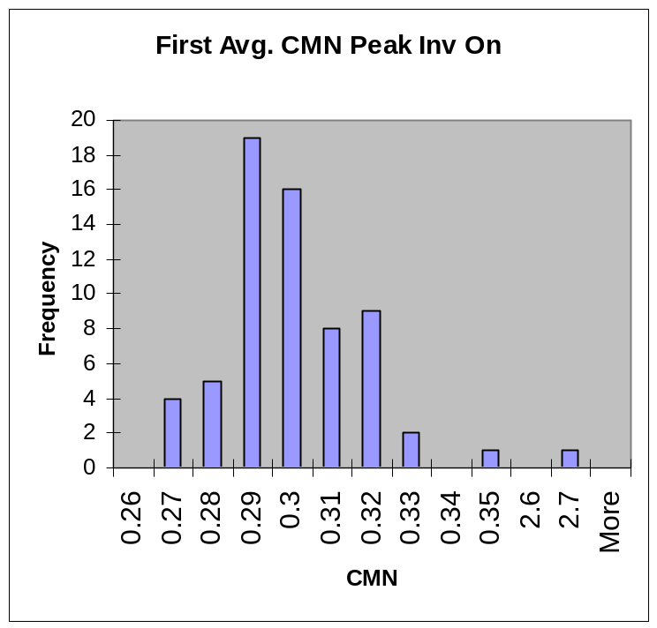 | 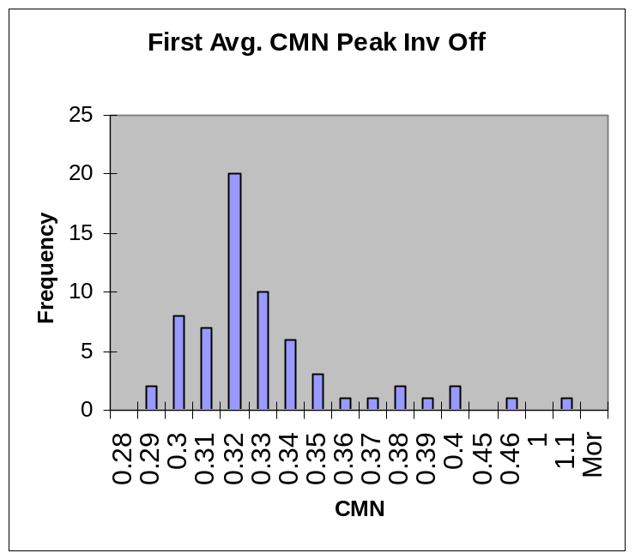
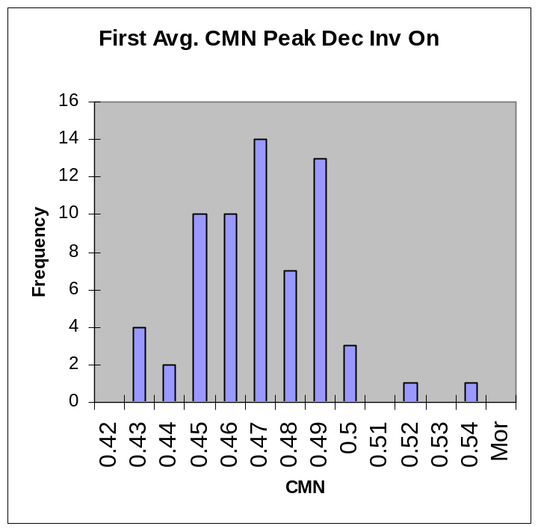 | 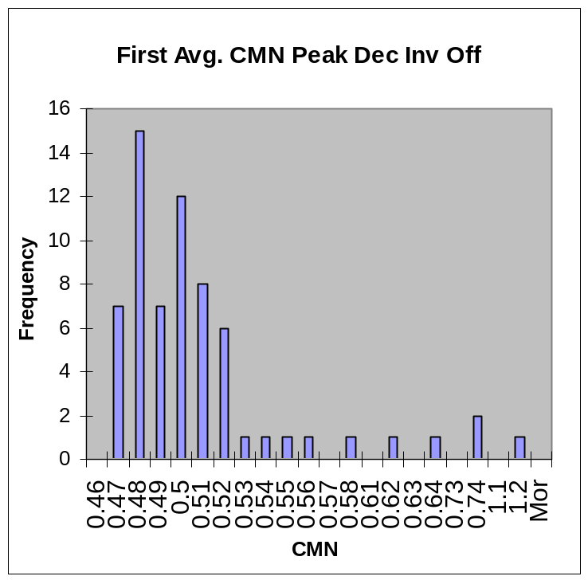

First Avg. Noise Histograms:
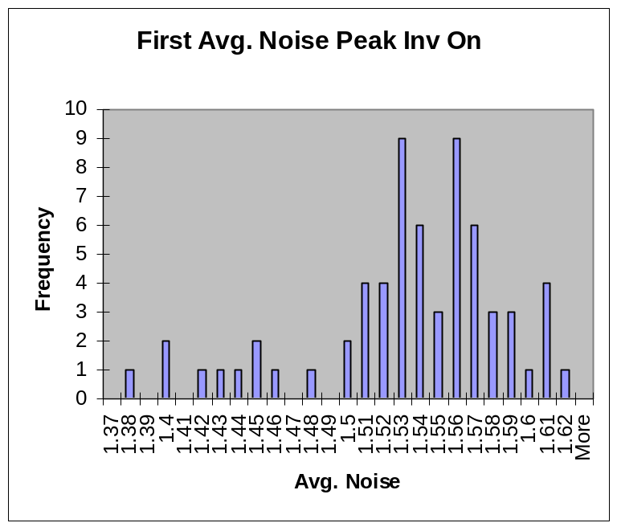 | 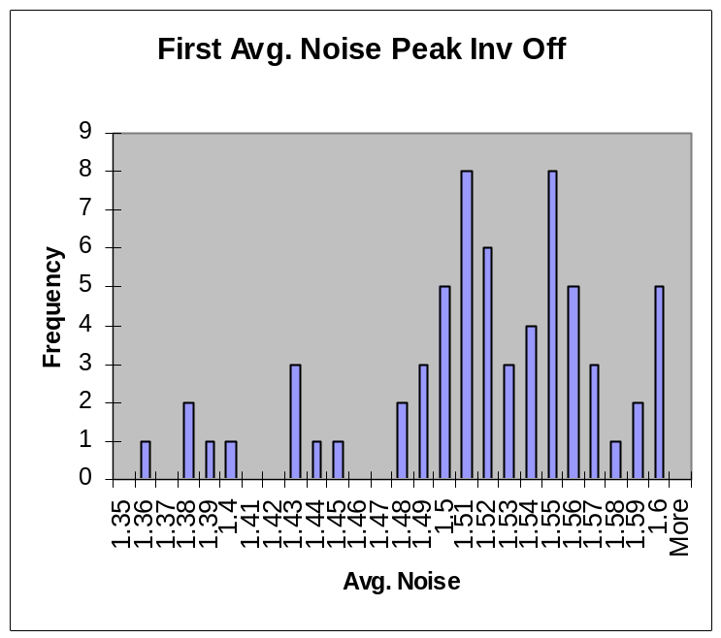
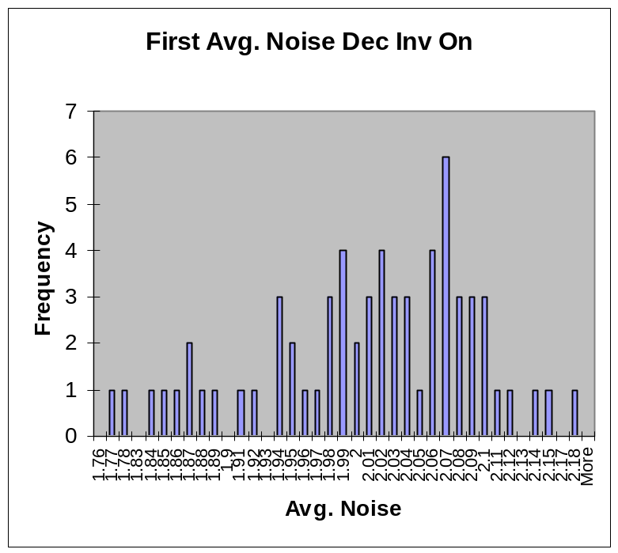 | 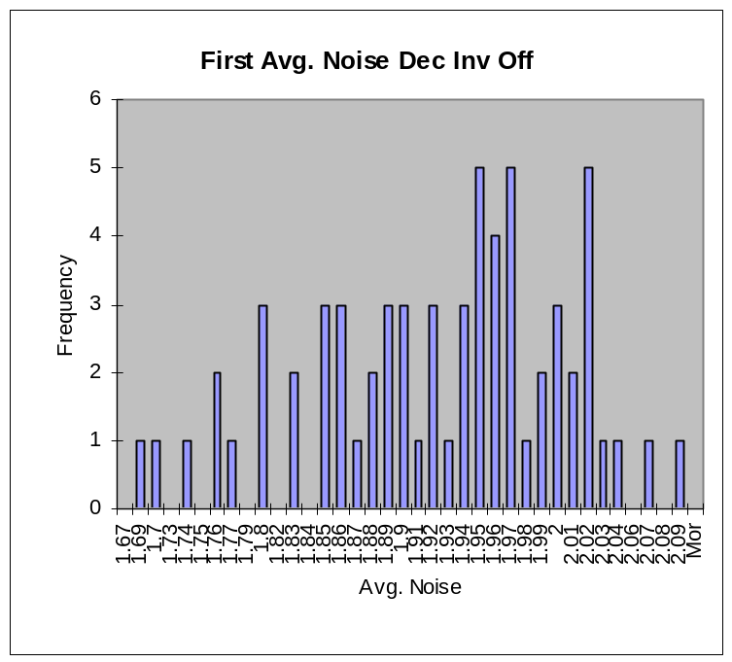

First Avg. Peak Time Histograms:
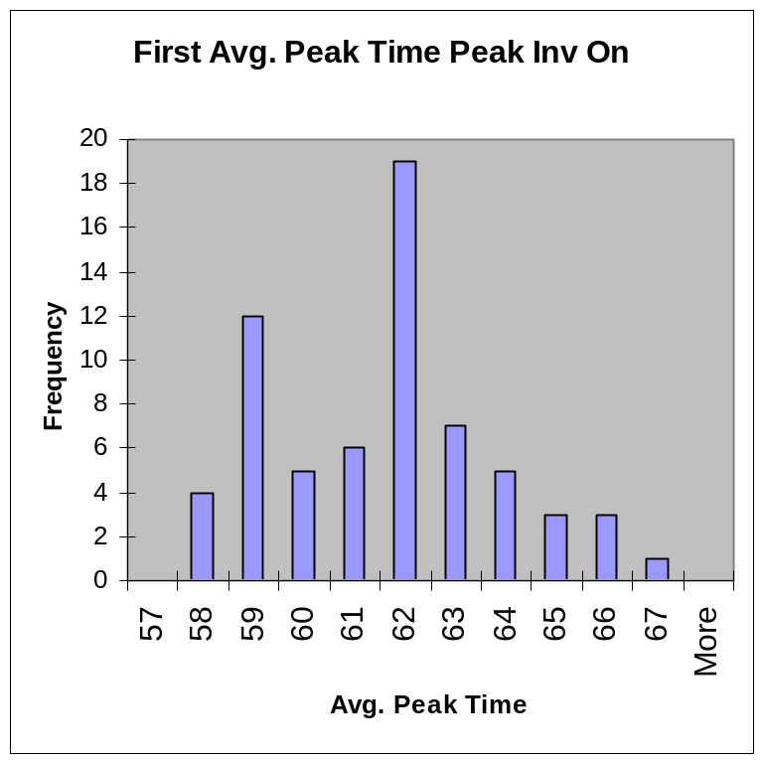 | 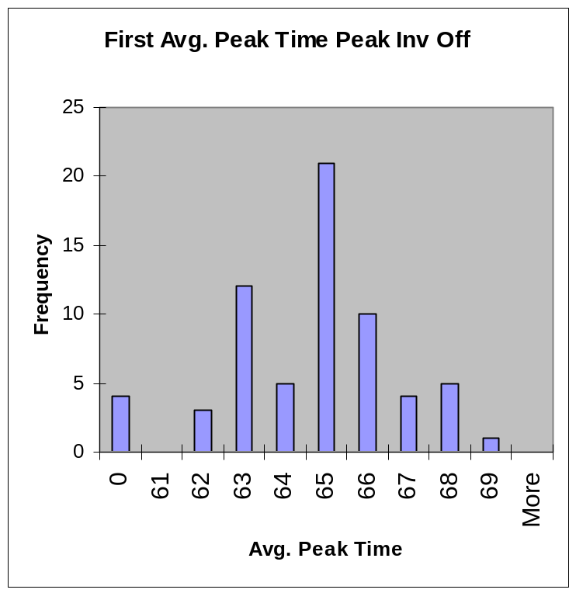
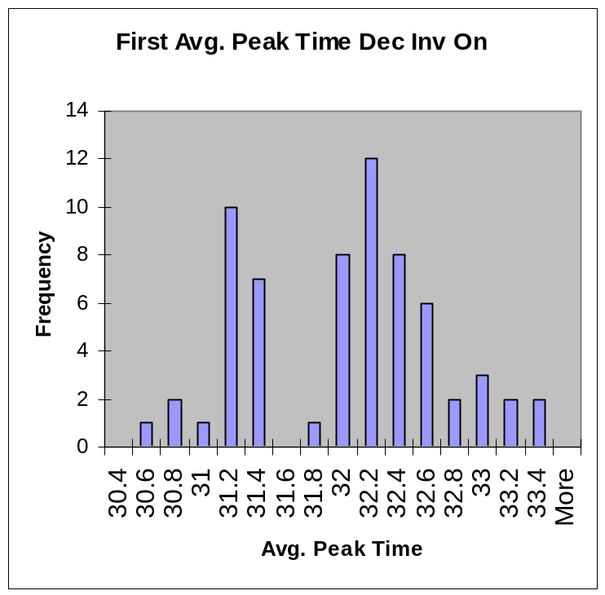 |  | 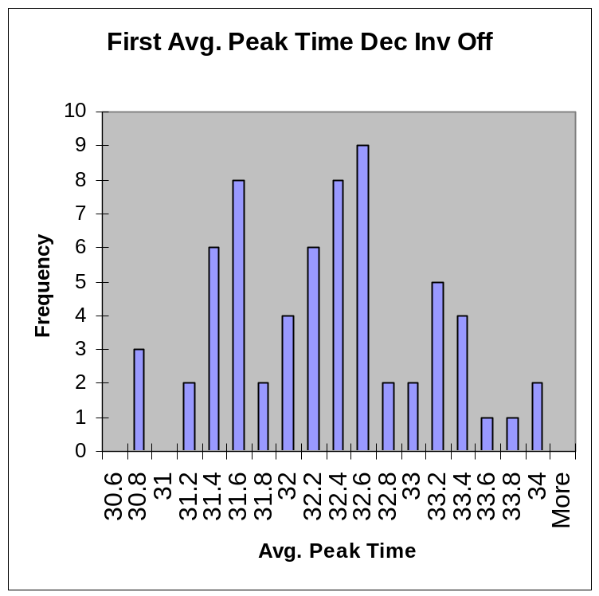

Cold Avg. CMN Histograms:
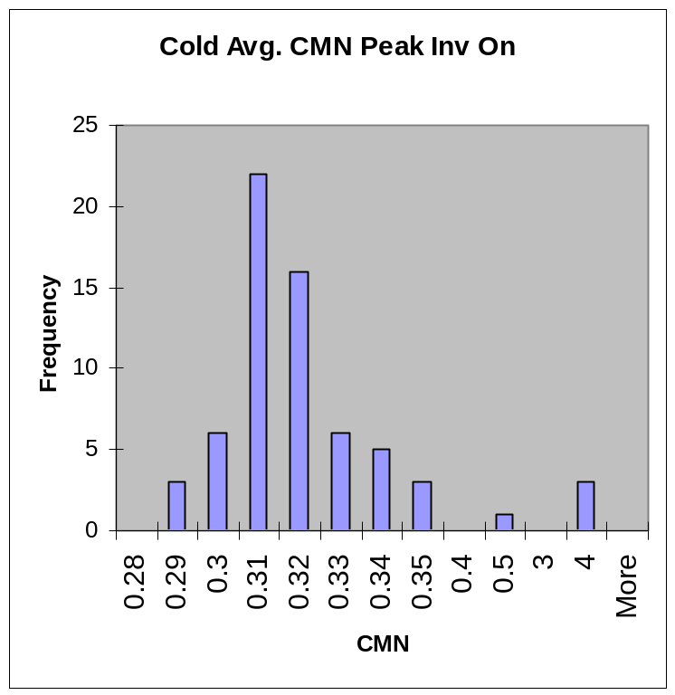 | 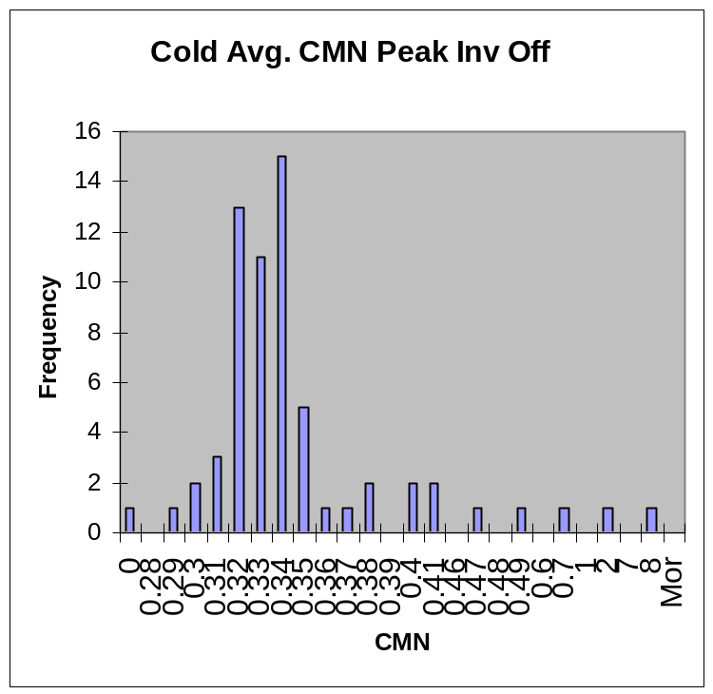
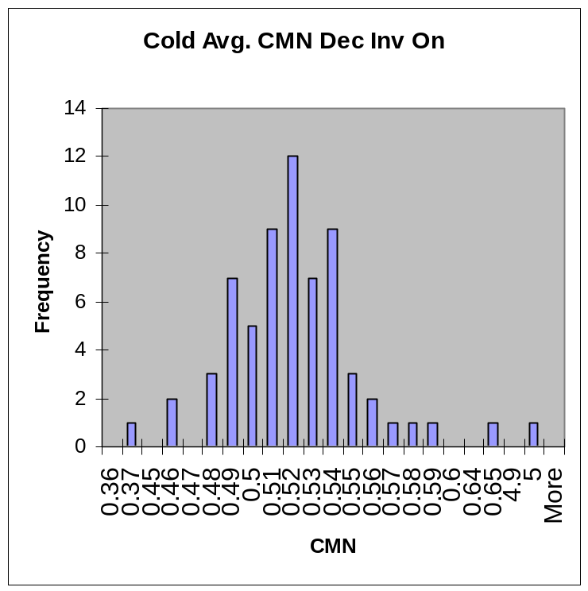 | 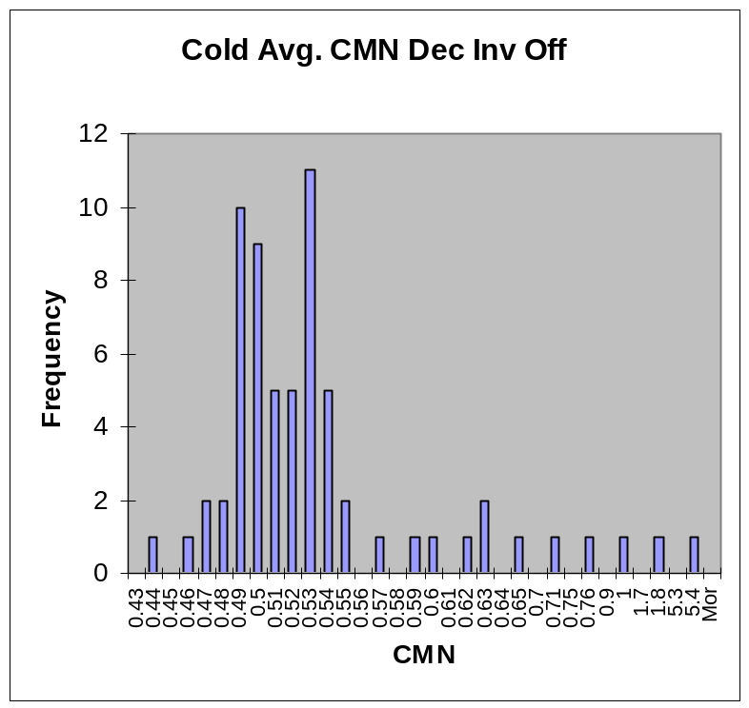

Cold Avg. Noise Histograms:
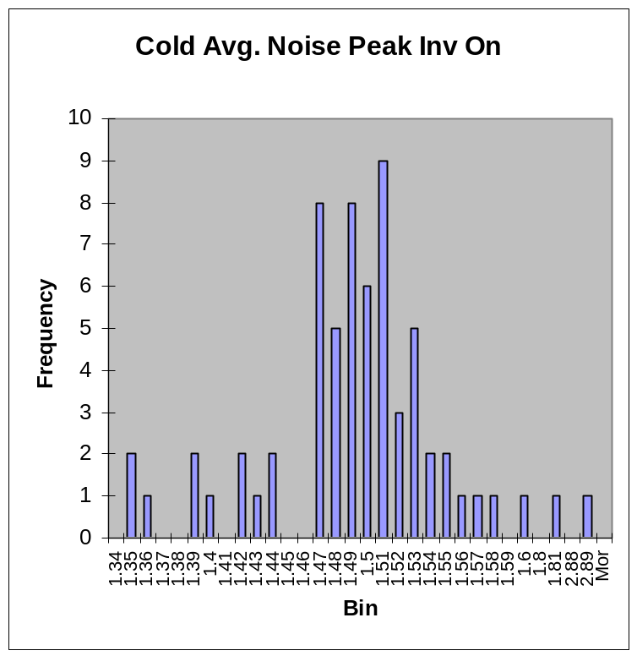 | 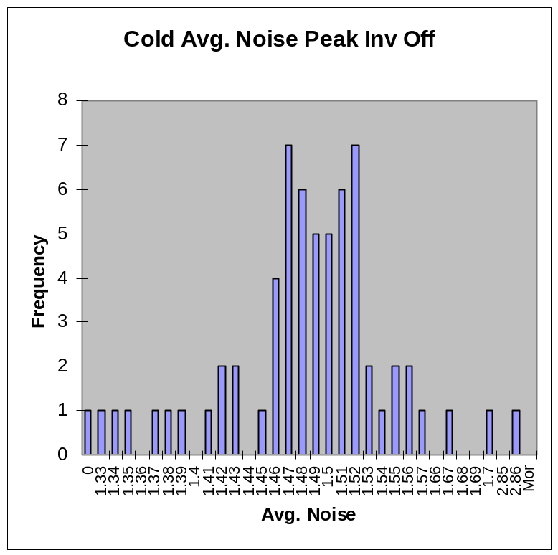
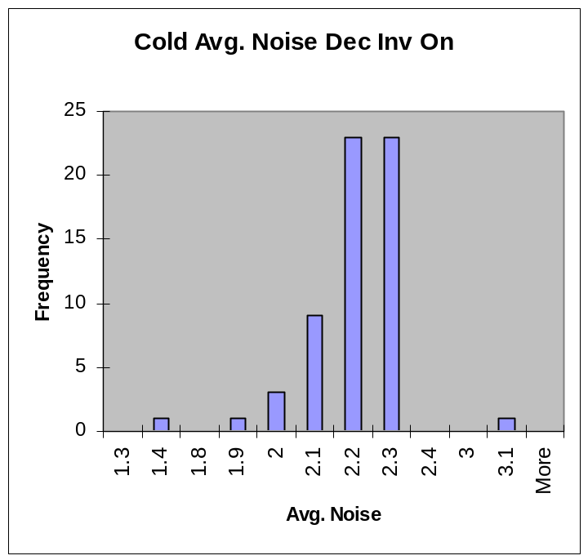 | 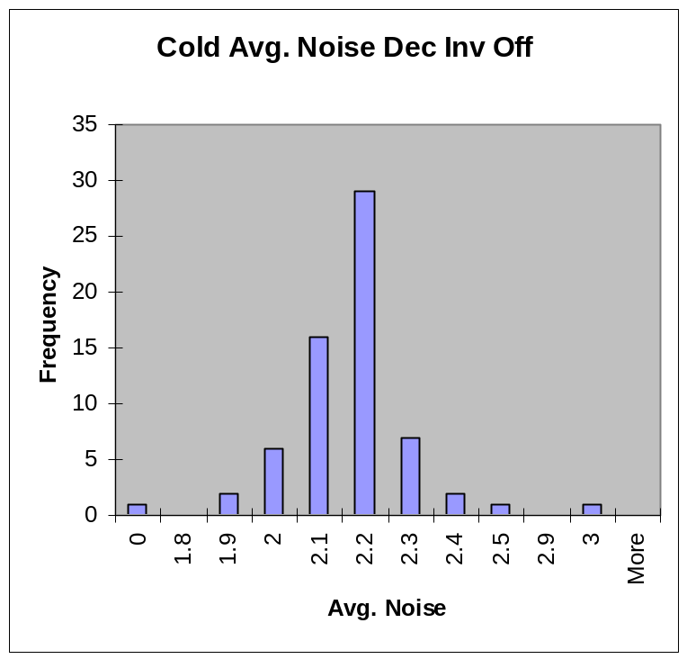

Cold Avg. Peak Time Histograms:
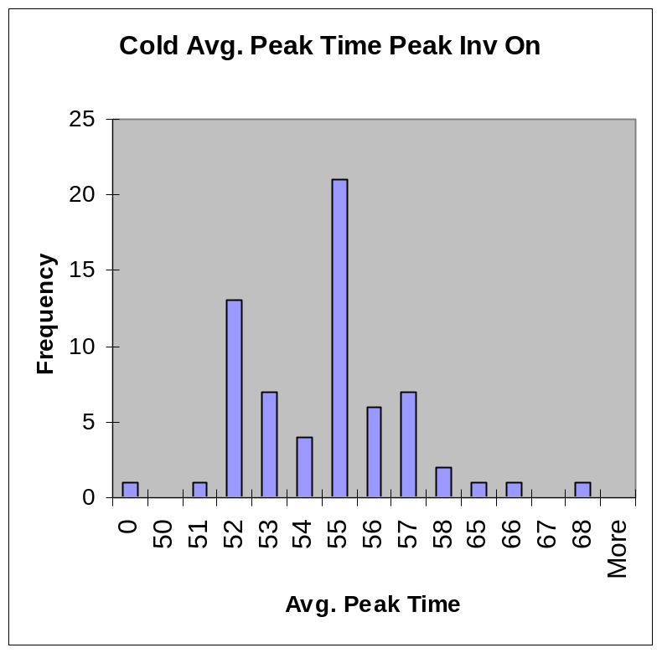 | 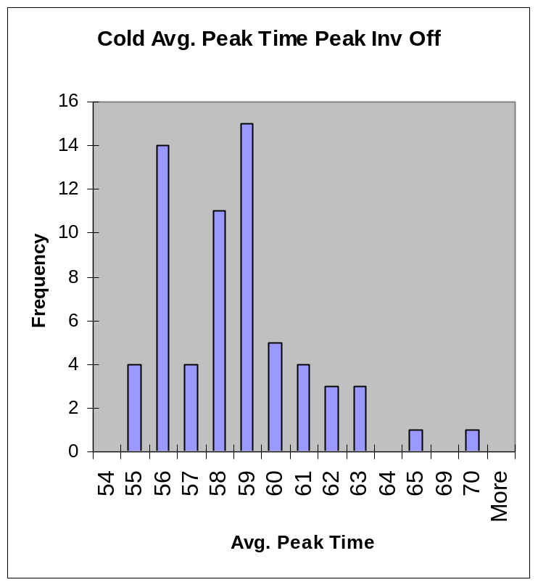
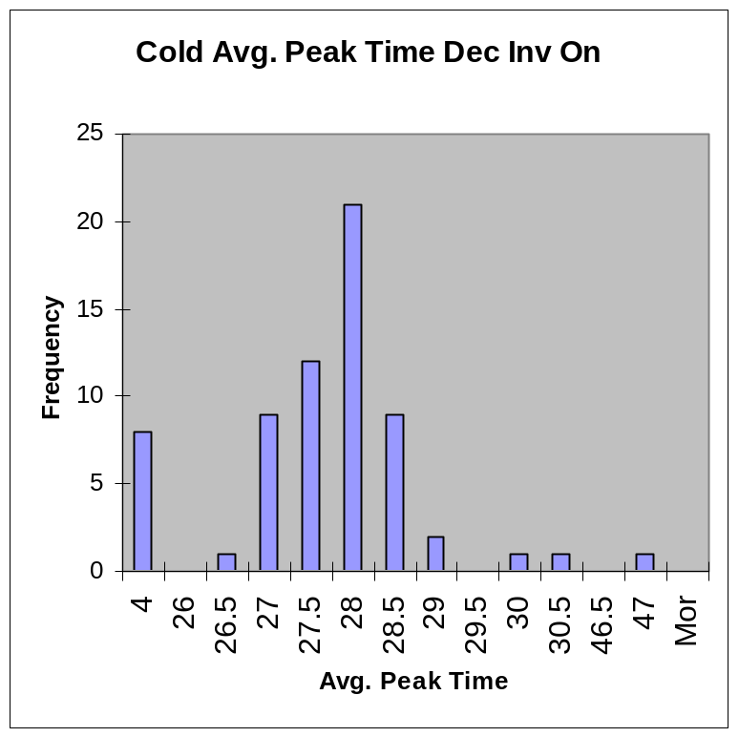 | 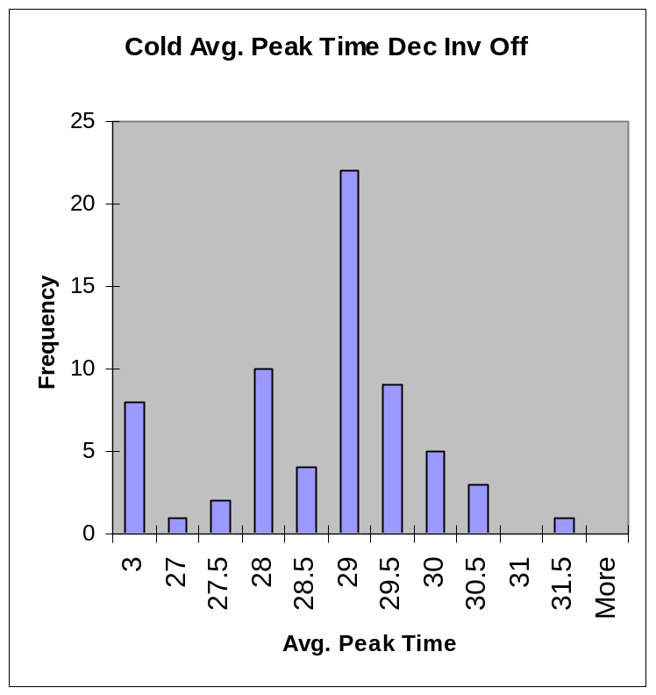

Last Avg. CMN Histograms:
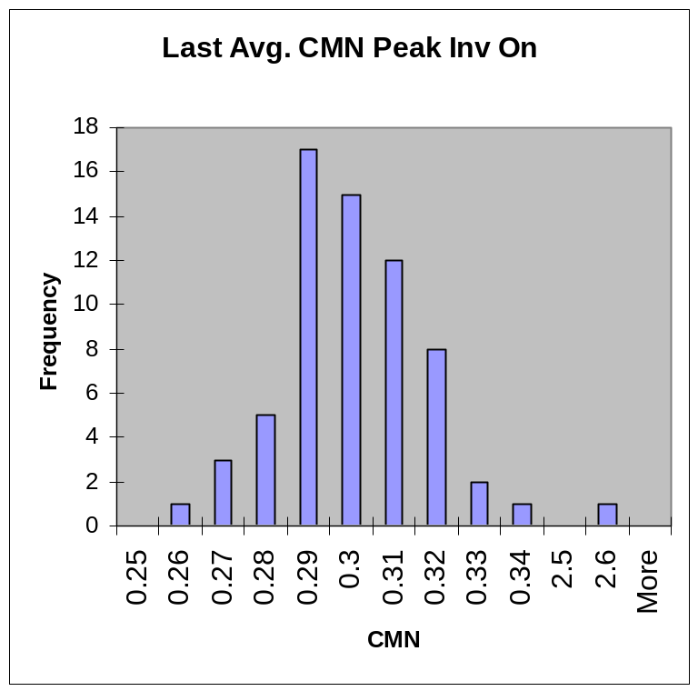 | 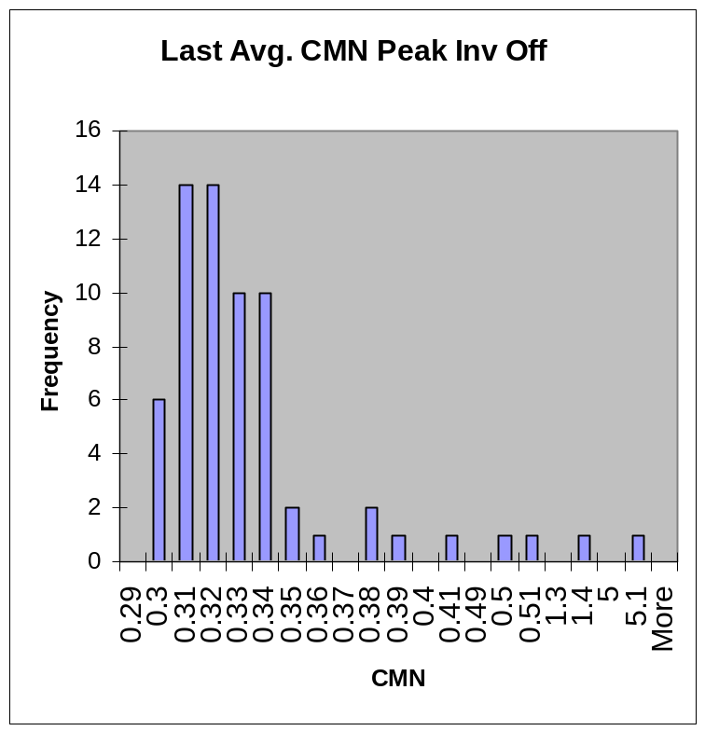
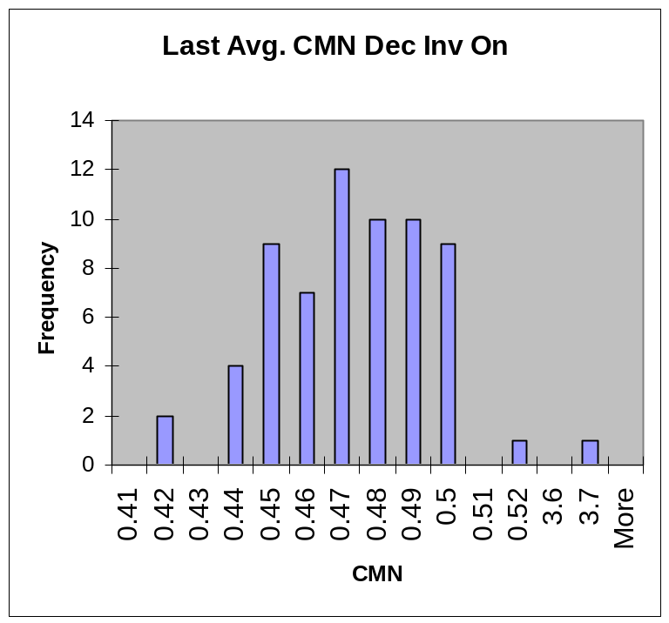 | 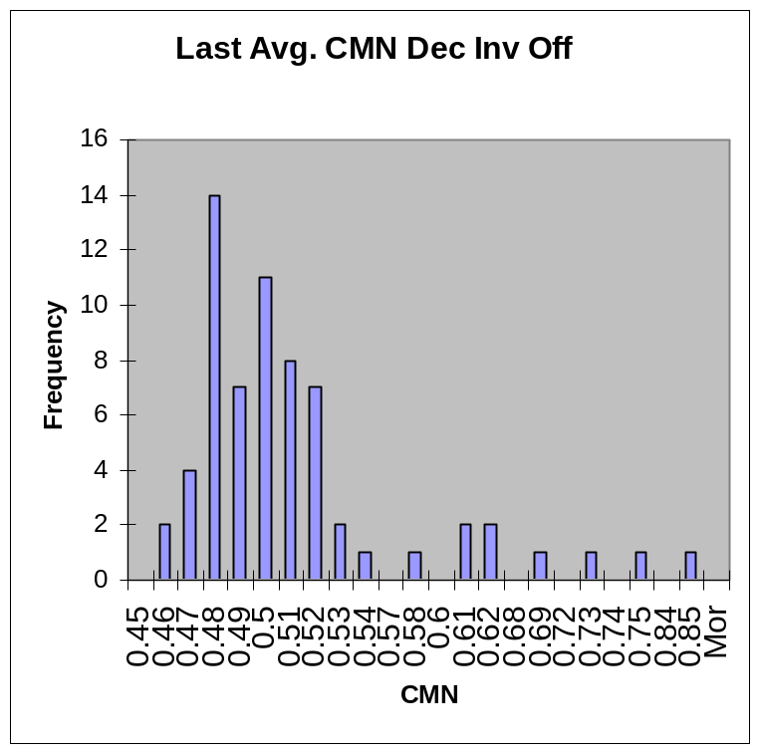

Last Avg. Noise Histograms:
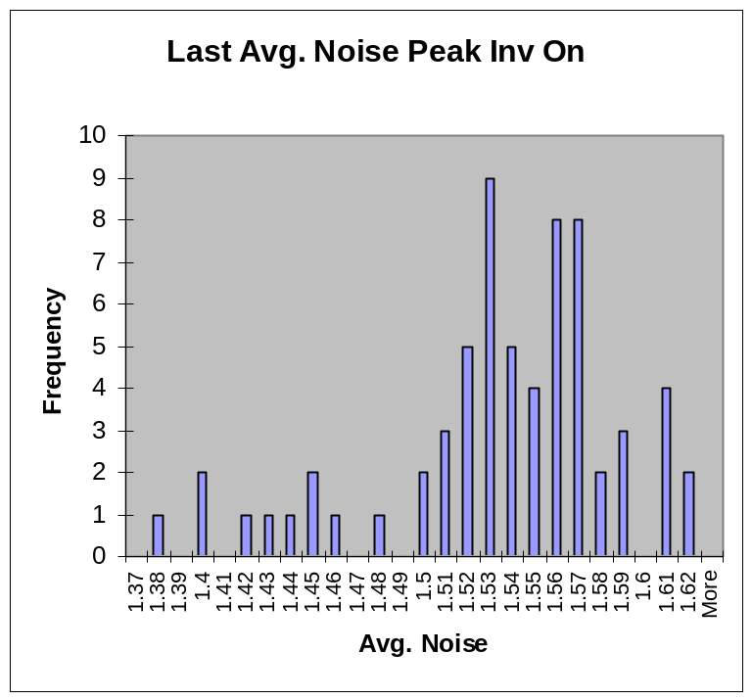 | 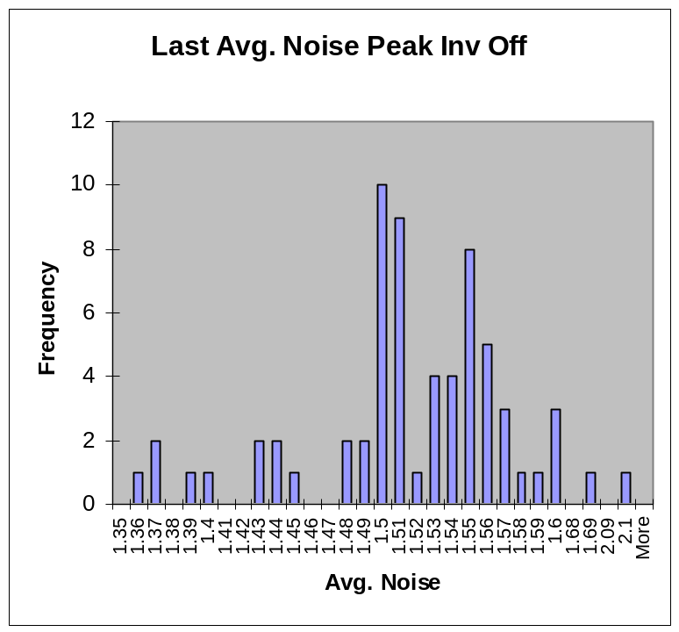
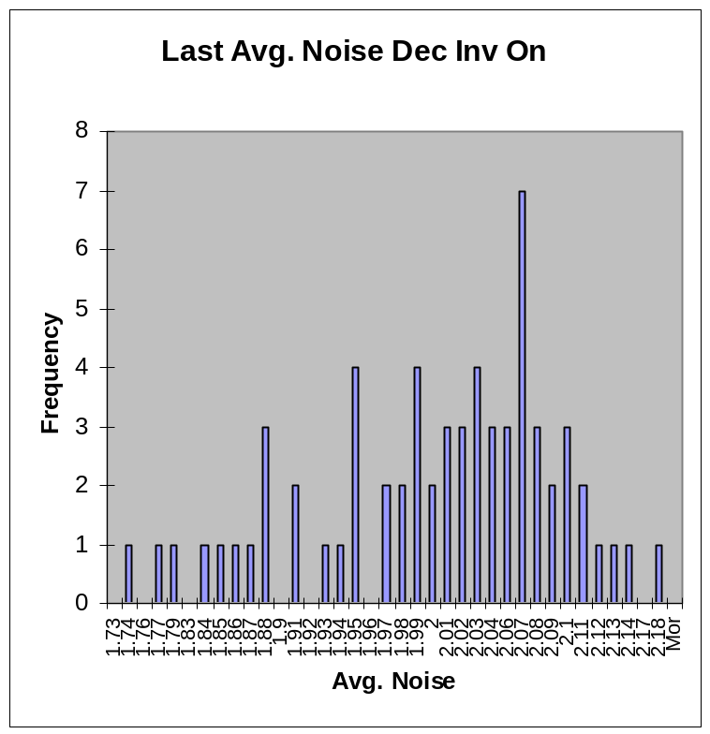 | 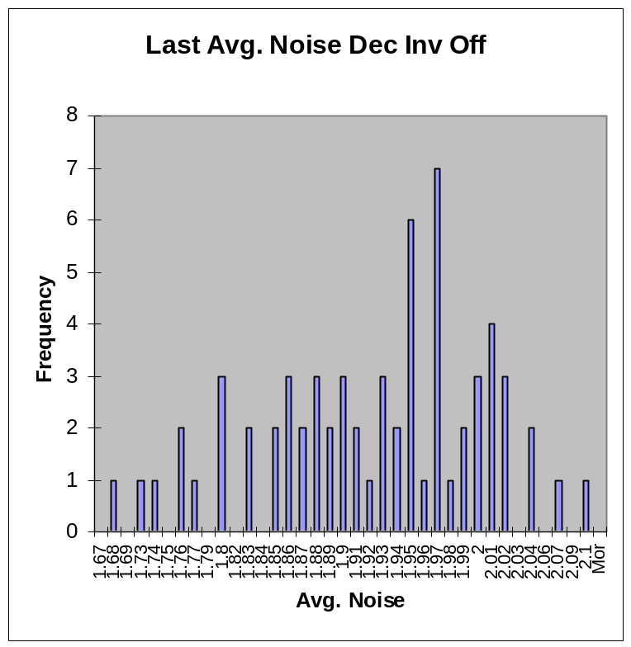

Last Avg. Peak Time Histograms:
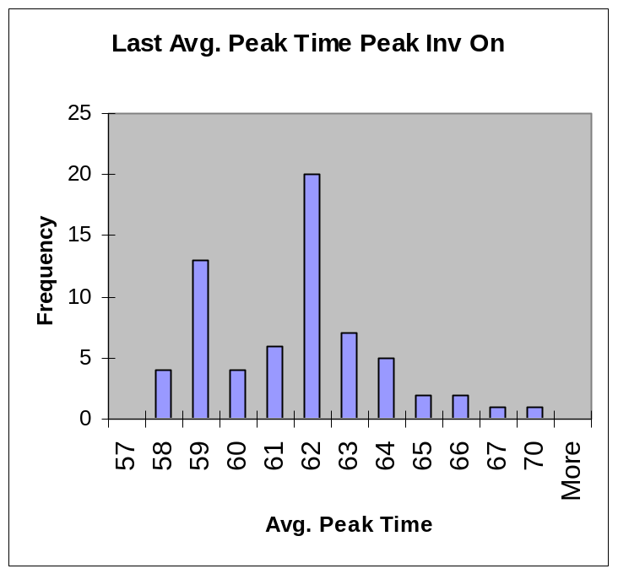 | 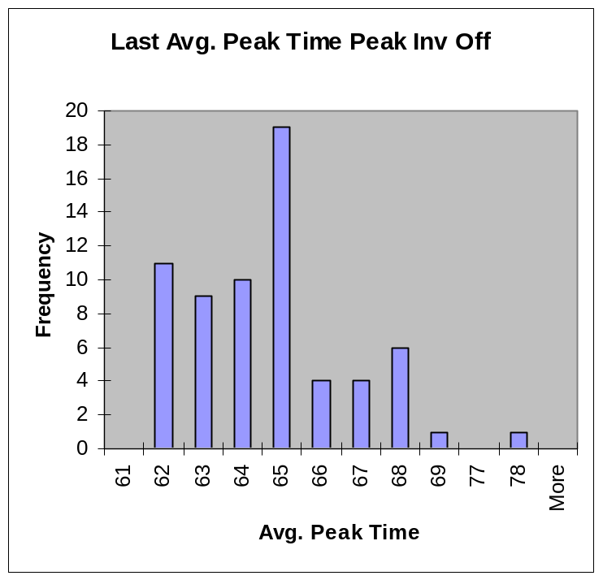
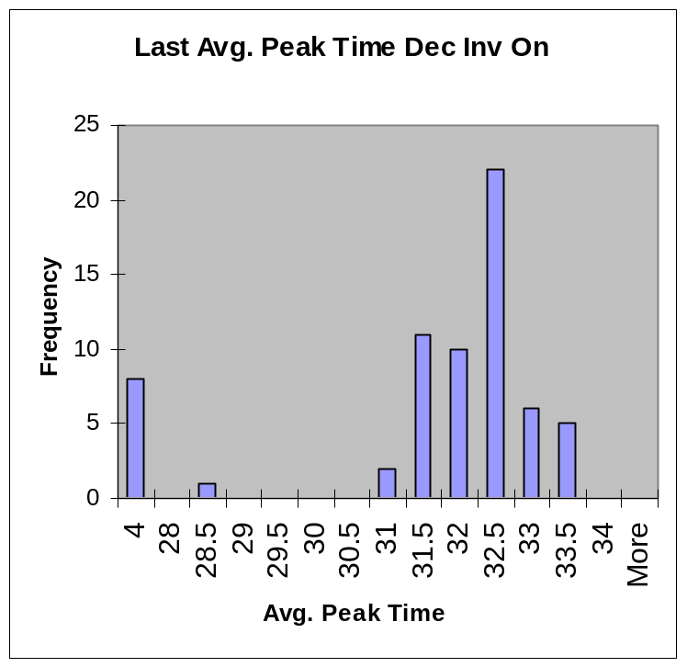 | 

