TOB Module Un-Tailing Certification

• The following individuals can train others in the proper procedures
for TOB module Un-Tailing.

Derek Barge

• The following individuals have been trained in the hybrid handling
procedures by someone authorized to do so in the list above.

Trainee | Trainer Authorization | Date

I. General Cleanliness

1) Hands:

- Gloves or finger cots must be used whenever a hybrid is
touched. DO NOT touch any part of any hybrid with a part
of your hand that is not protected by gloves or finger cots.

2) Face & Hair:

- A face mask must be worn at all times while handling hybrids,
and at all times working near an exposed hybrid (an exposed
hybrid is one that is not in a sealed hybrid box). The face mask
must fully cover the mouth and nose.

- A hairnet must be worn inside the clean rooms at all times.

3) Feet:

- Clean booties must be worn inside the clean rooms at all times.

- Grounding straps must be worn any time a hybrid is being
handled. Contact must be checked at a DESCO ‘touch tester’
or at the large DESCO ‘WRIST STRAP / FOOTWEAR tester’ in
the main clean room before handling hybrids.

4) Body:

- A lab coat must be worn inside the clean rooms at all times.
Make sure your lab coat was designed for clean room use.

TOB Module Un-Tailing Procedure

- If anything does not go according to this procedure, or you are
unsure about what you are doing, stop immediately and contact a
supervisor. DO NOT continue to work until a supervisor is available.

*No tools, fingers, or other objects should be held directly above the
module at any time.

1) Carefully remove the lower high and low voltage clamp or clamps.

- If the high voltage is on the right, remove the lower wide clamp securing
the high voltage and low voltage test tails.

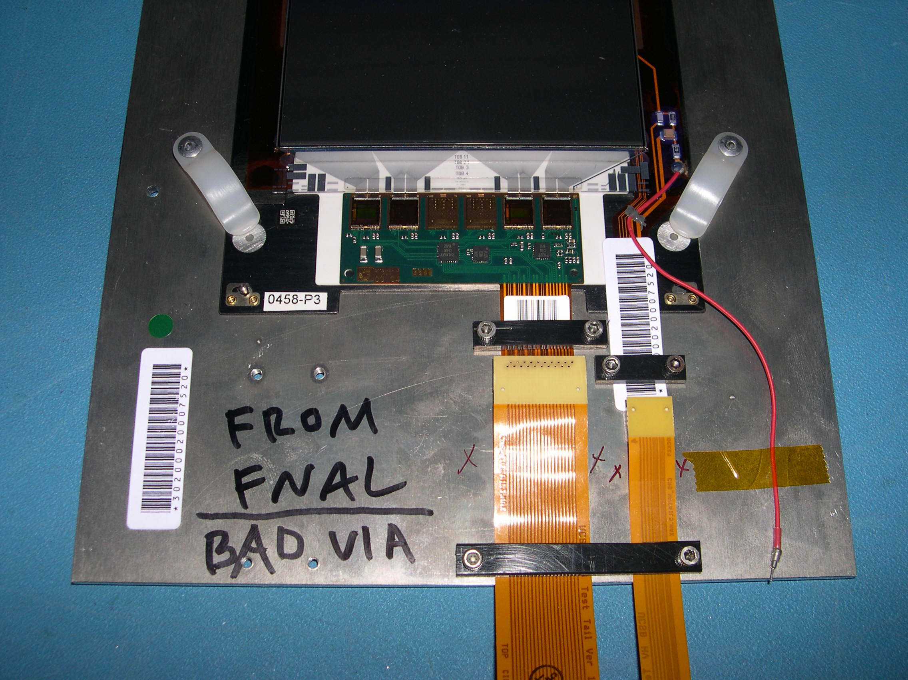

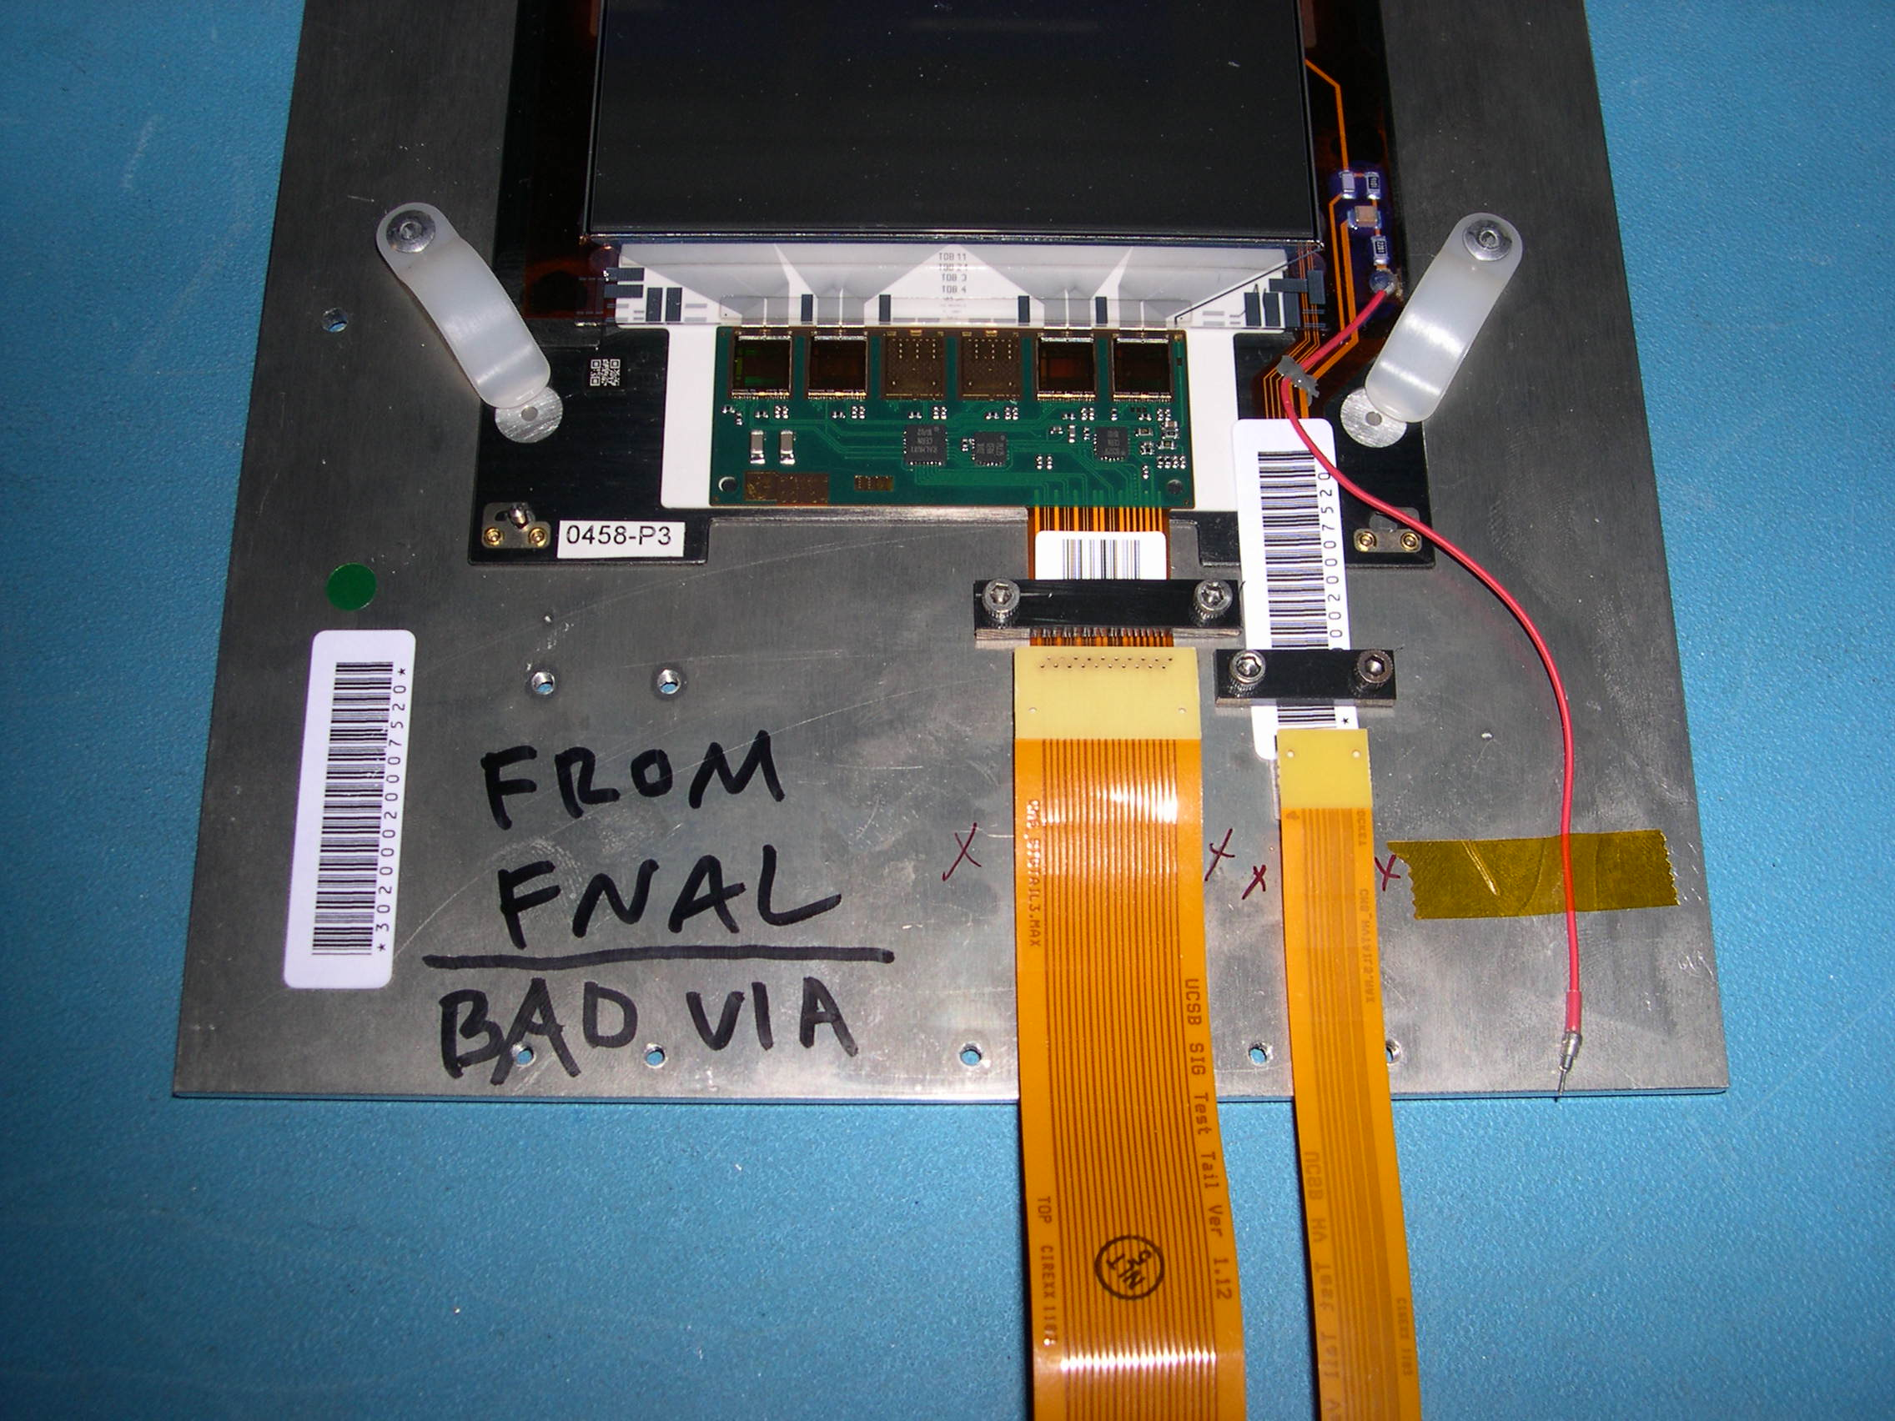
- If the high voltage is on the left, remove the lower high voltage clamp and
the lower low voltage clamp.

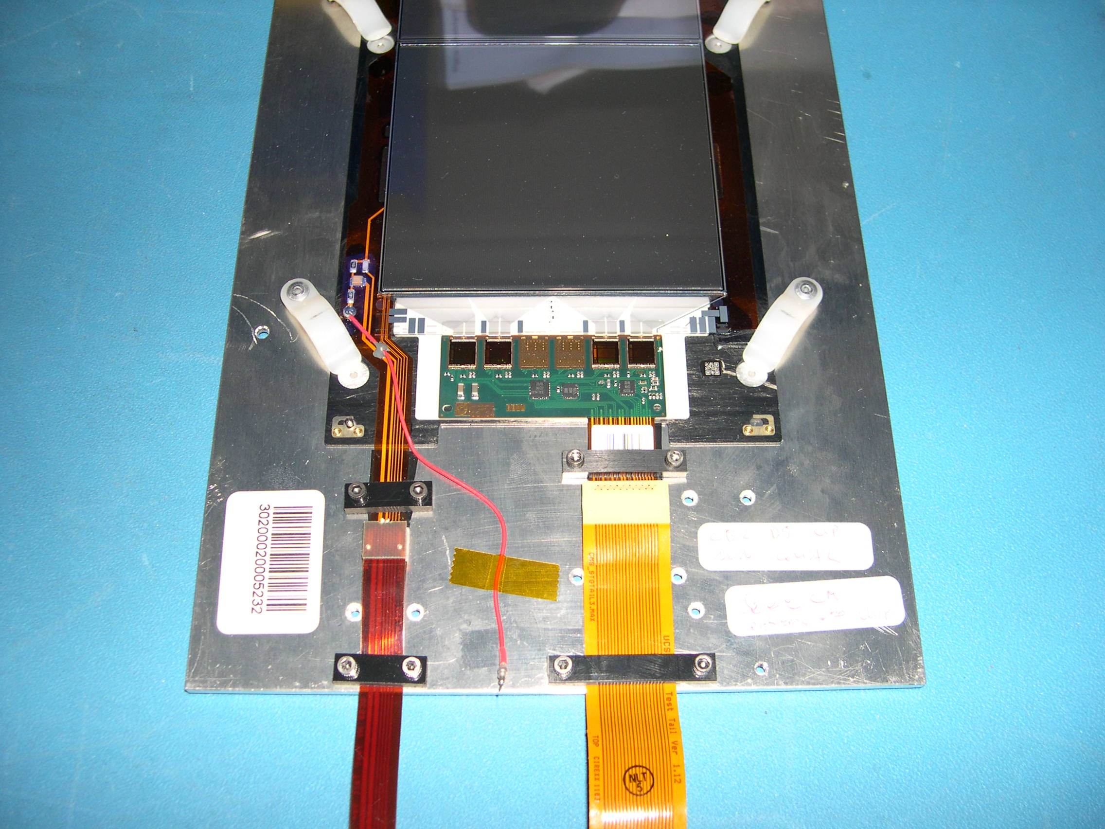

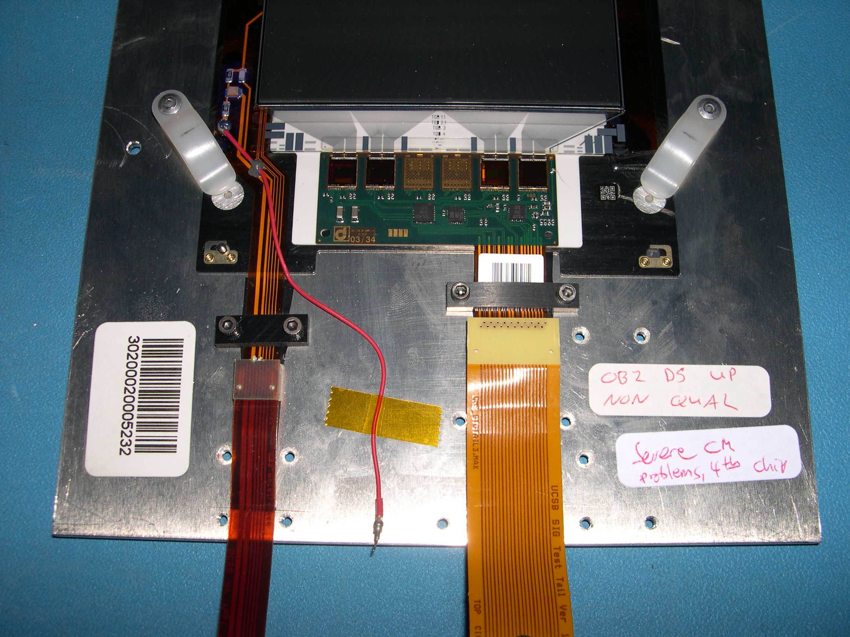

2) Carefully remove the high voltage tail. Use a flat head jewelers screw driver with a
1/8" blade.

- Take a small flat head jewelers screw driver and place the edge of the flat
head in the top seam between the high voltage connector and the high
voltage tail. Make sure not to pry the connector mounted on the high
voltage tail against the high voltage tail.

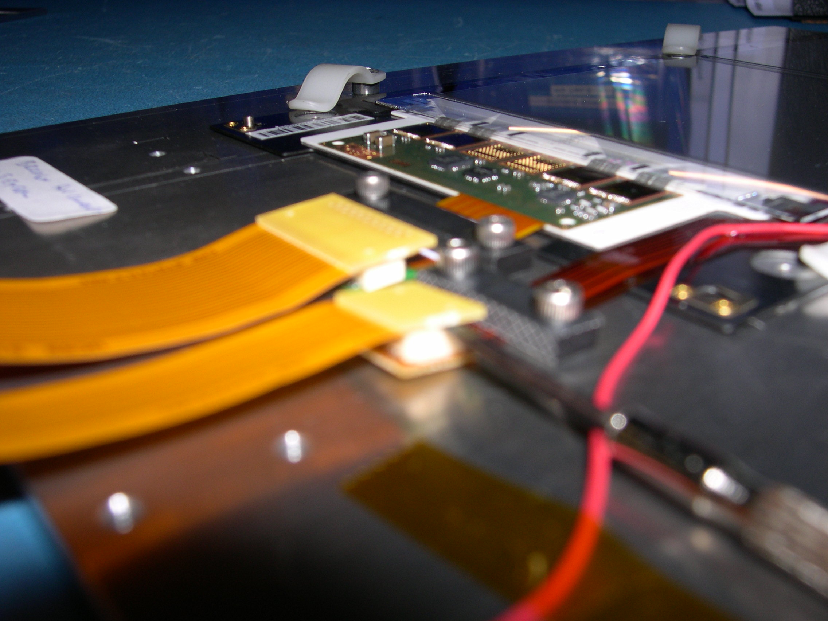

- Rotate the driver 90°, this will free one side of the connector.

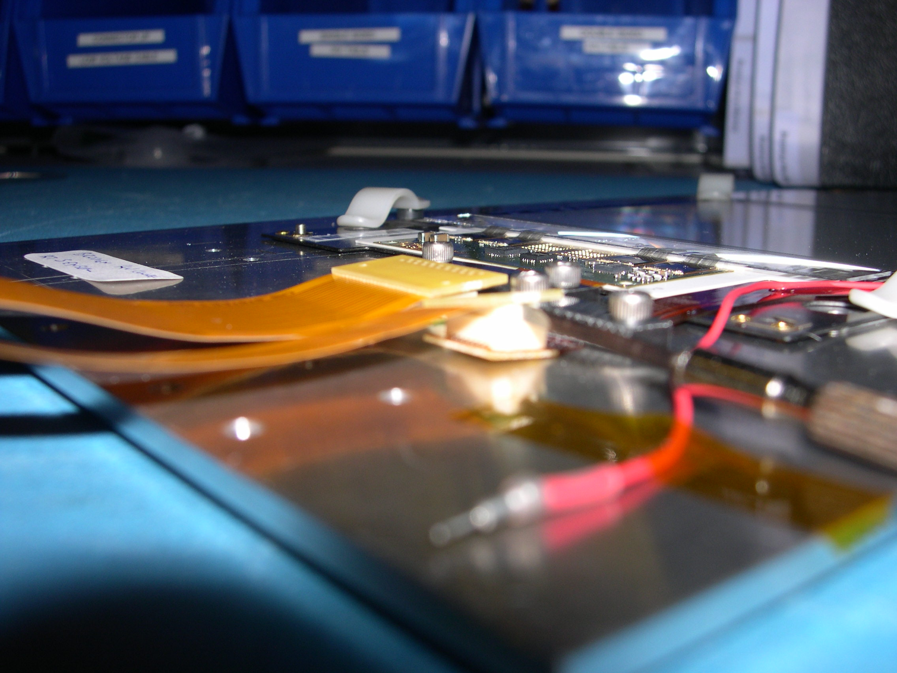

- Gently grasp the high voltage test tail and gently wiggle it free. There
should be very little to resistance; do not force.

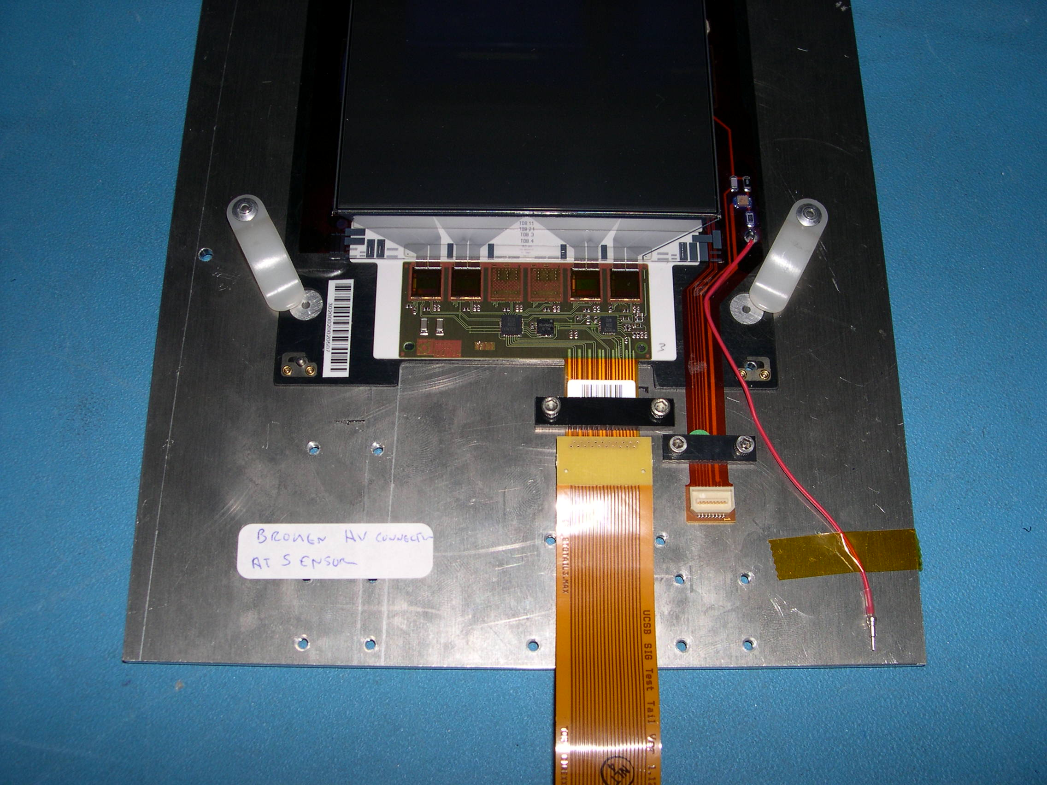
3) Cautiously, remove the hybrid tail. Follow a) for modules with hybrids having up
connectors and b) for modules with hybrids having down connectors. Use a flat
head jewelers screw driver with a 1/8" blade.

a) Hybrids with ‘Up’ connectors

- Take a small flat head jewelers screw driver and place the edge
of the flat head in the top seam between the hybrid connector and
the test tail. Make sure not to pry the connector mounted
on the hybrid tail against the hybrid tail.

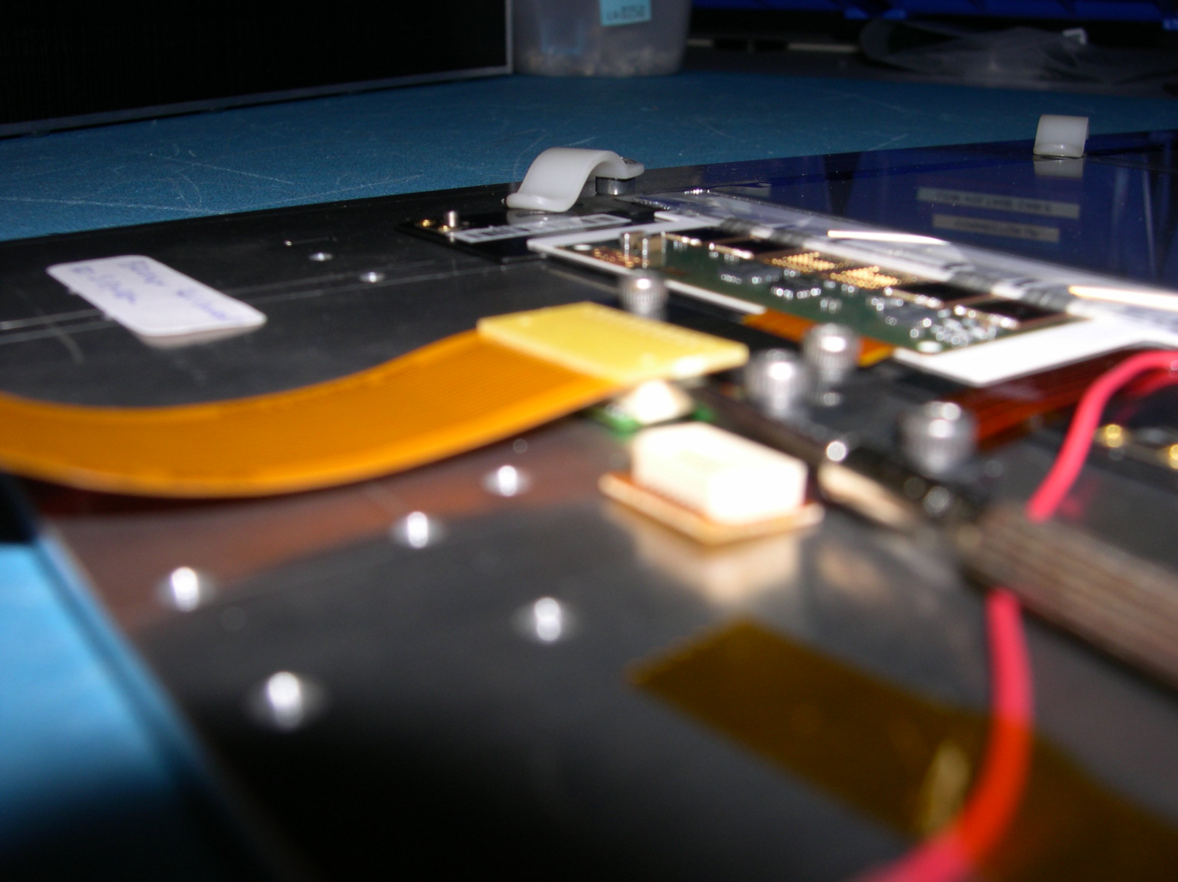

- Rotate the driver 90°, this will free one side of the connector.

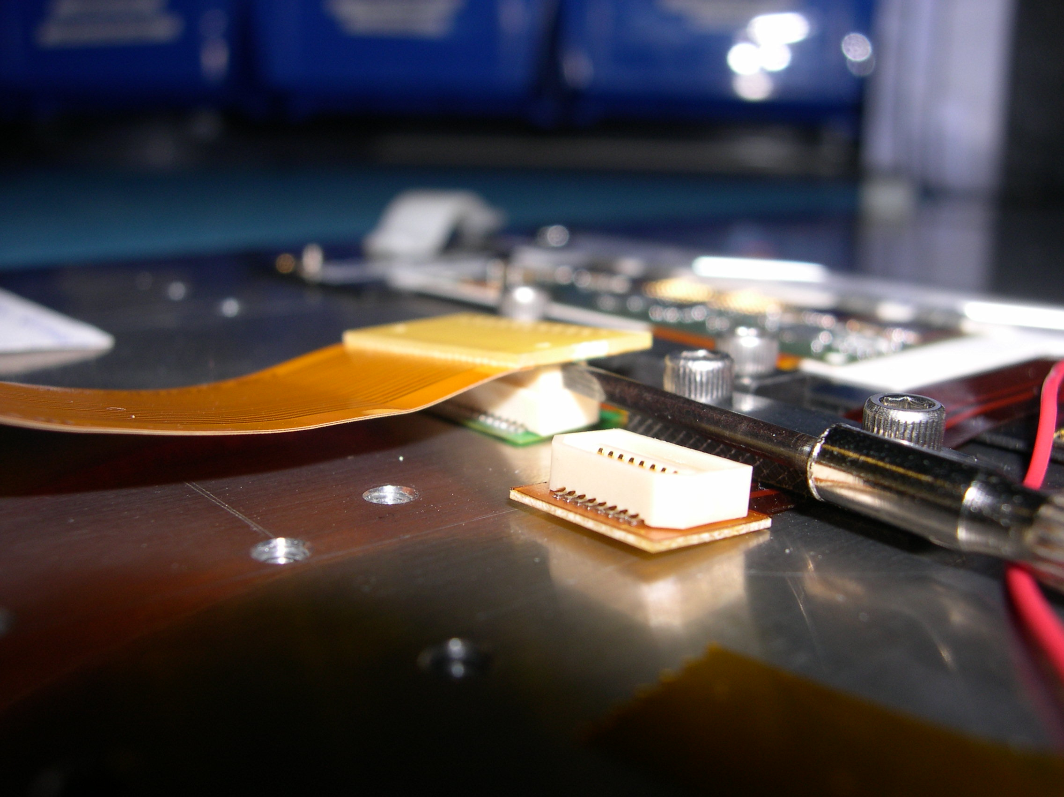
- Very gently push down on the SAME SIDE side of the connector
that was just freed in the upper right hand corner, this should release the test tail
from the connector.

- If the test tail does not come completely free, gently grasp both ends and
gently wiggle it free. There should be very little to no resistance.

- Gently remove the hybrid tail.

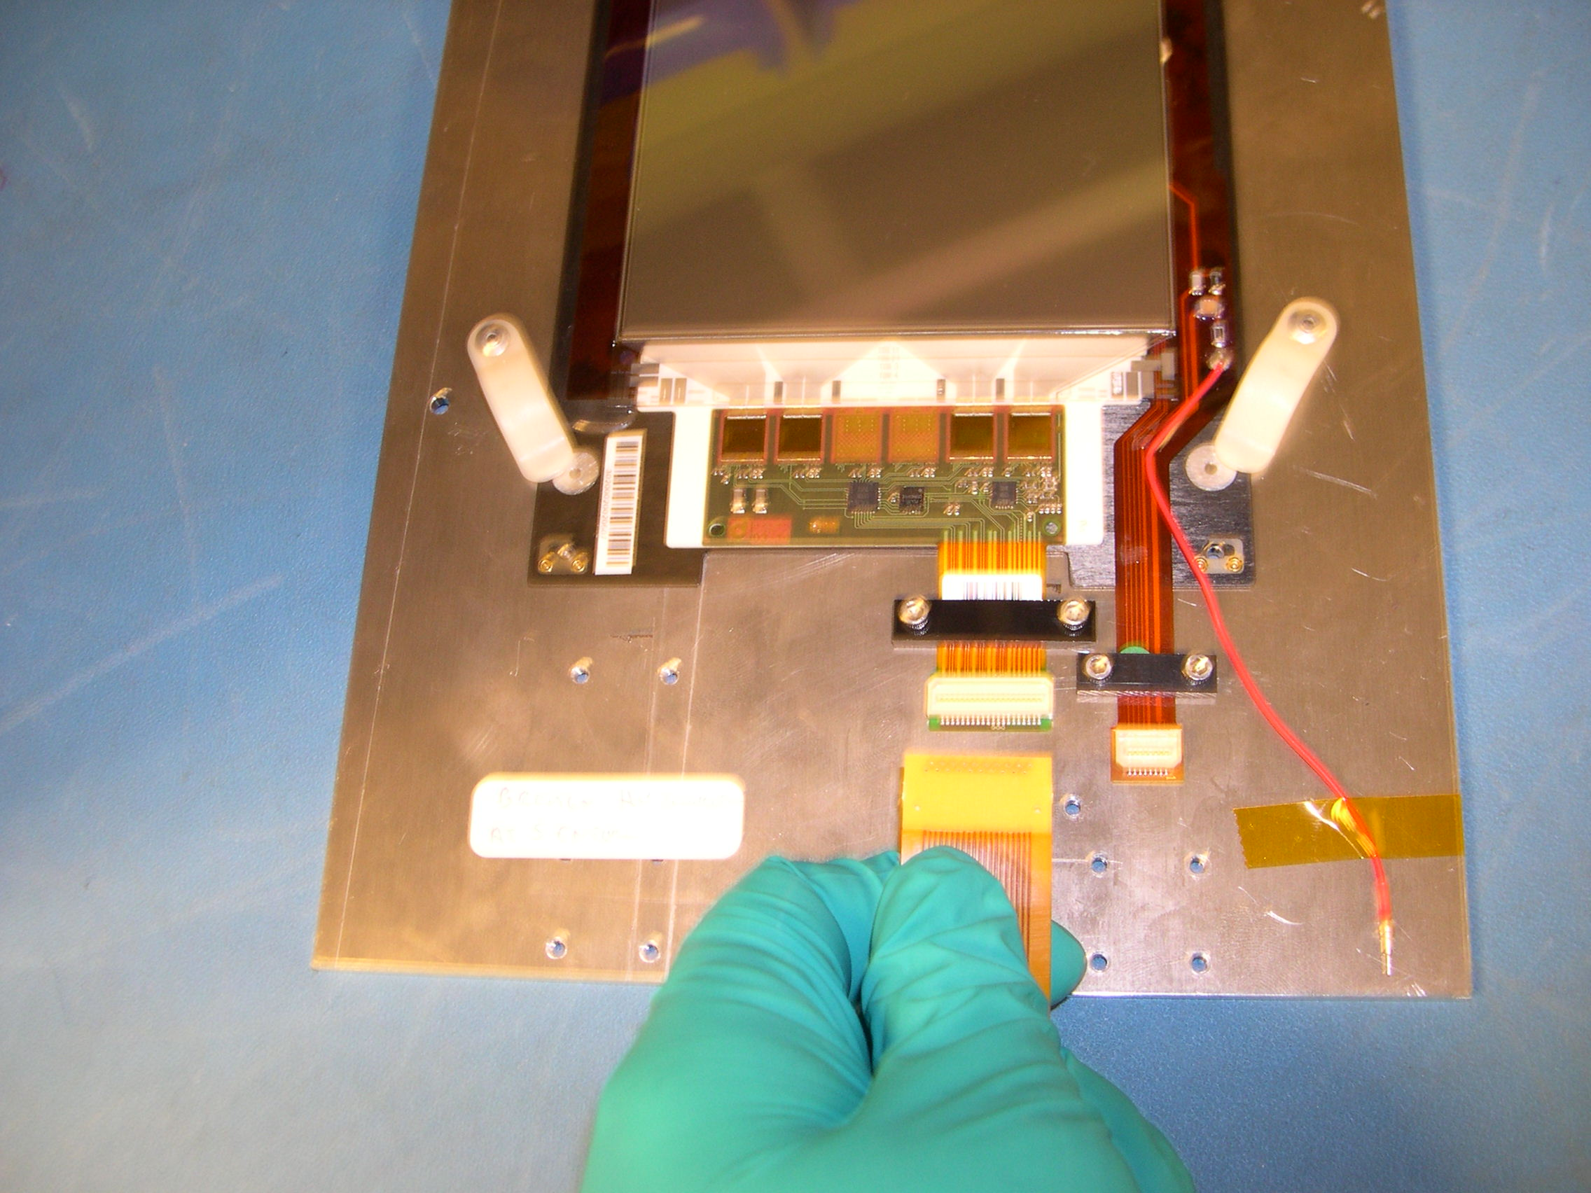

b) Hybrids with ‘down’ connectors

* Examples shown are with TOB hybrid only, but the procedure is no different
for a TOB module.

- Take a small flat head jewelers screw driver and place the edge
of the flat head in the bottom seam between the hybrid connector and
the test tail. Make sure not to pry the connector mounted
on the hybrid tail against the hybrid tail.

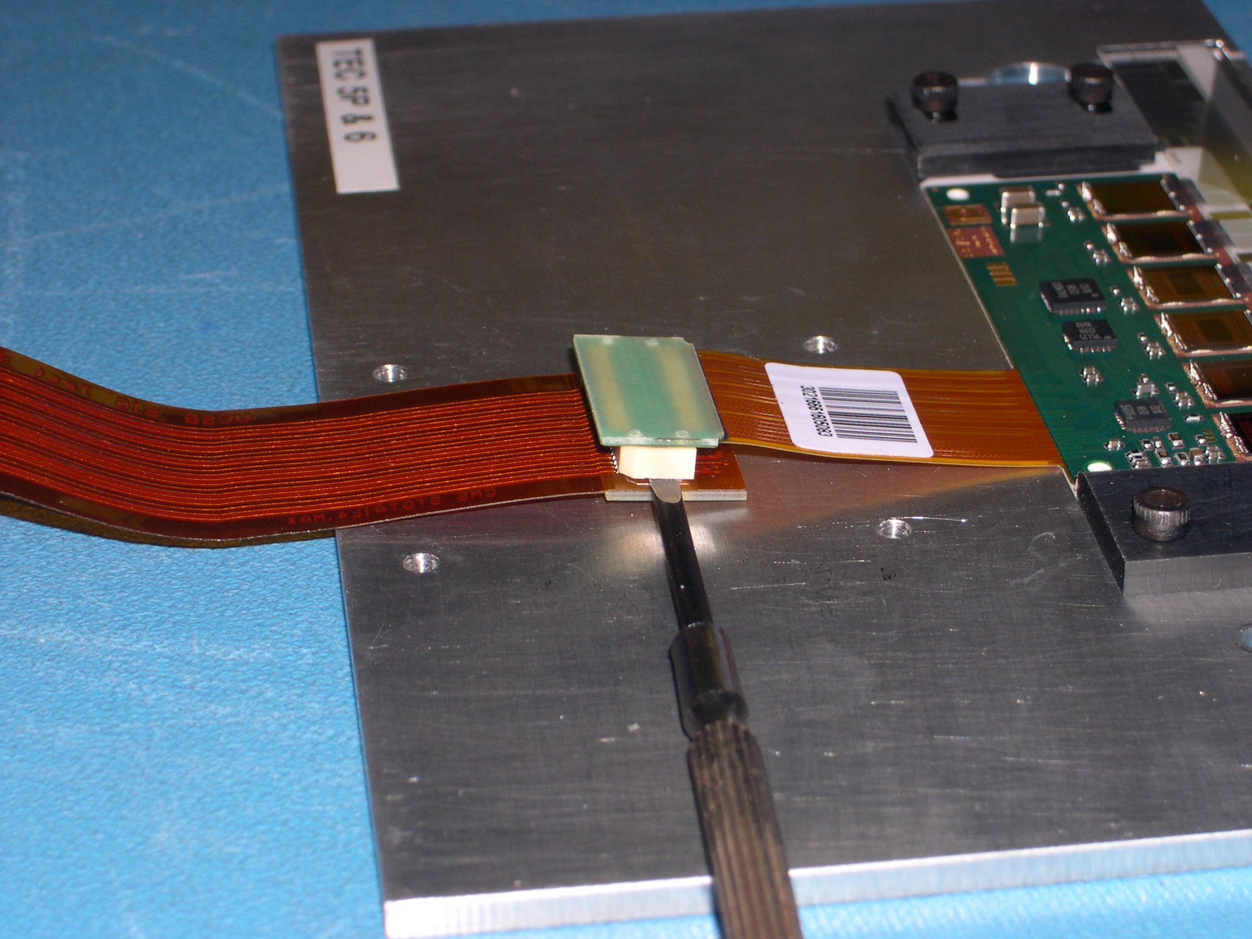

- Rotate the driver 90°, this will free one side of the connector.

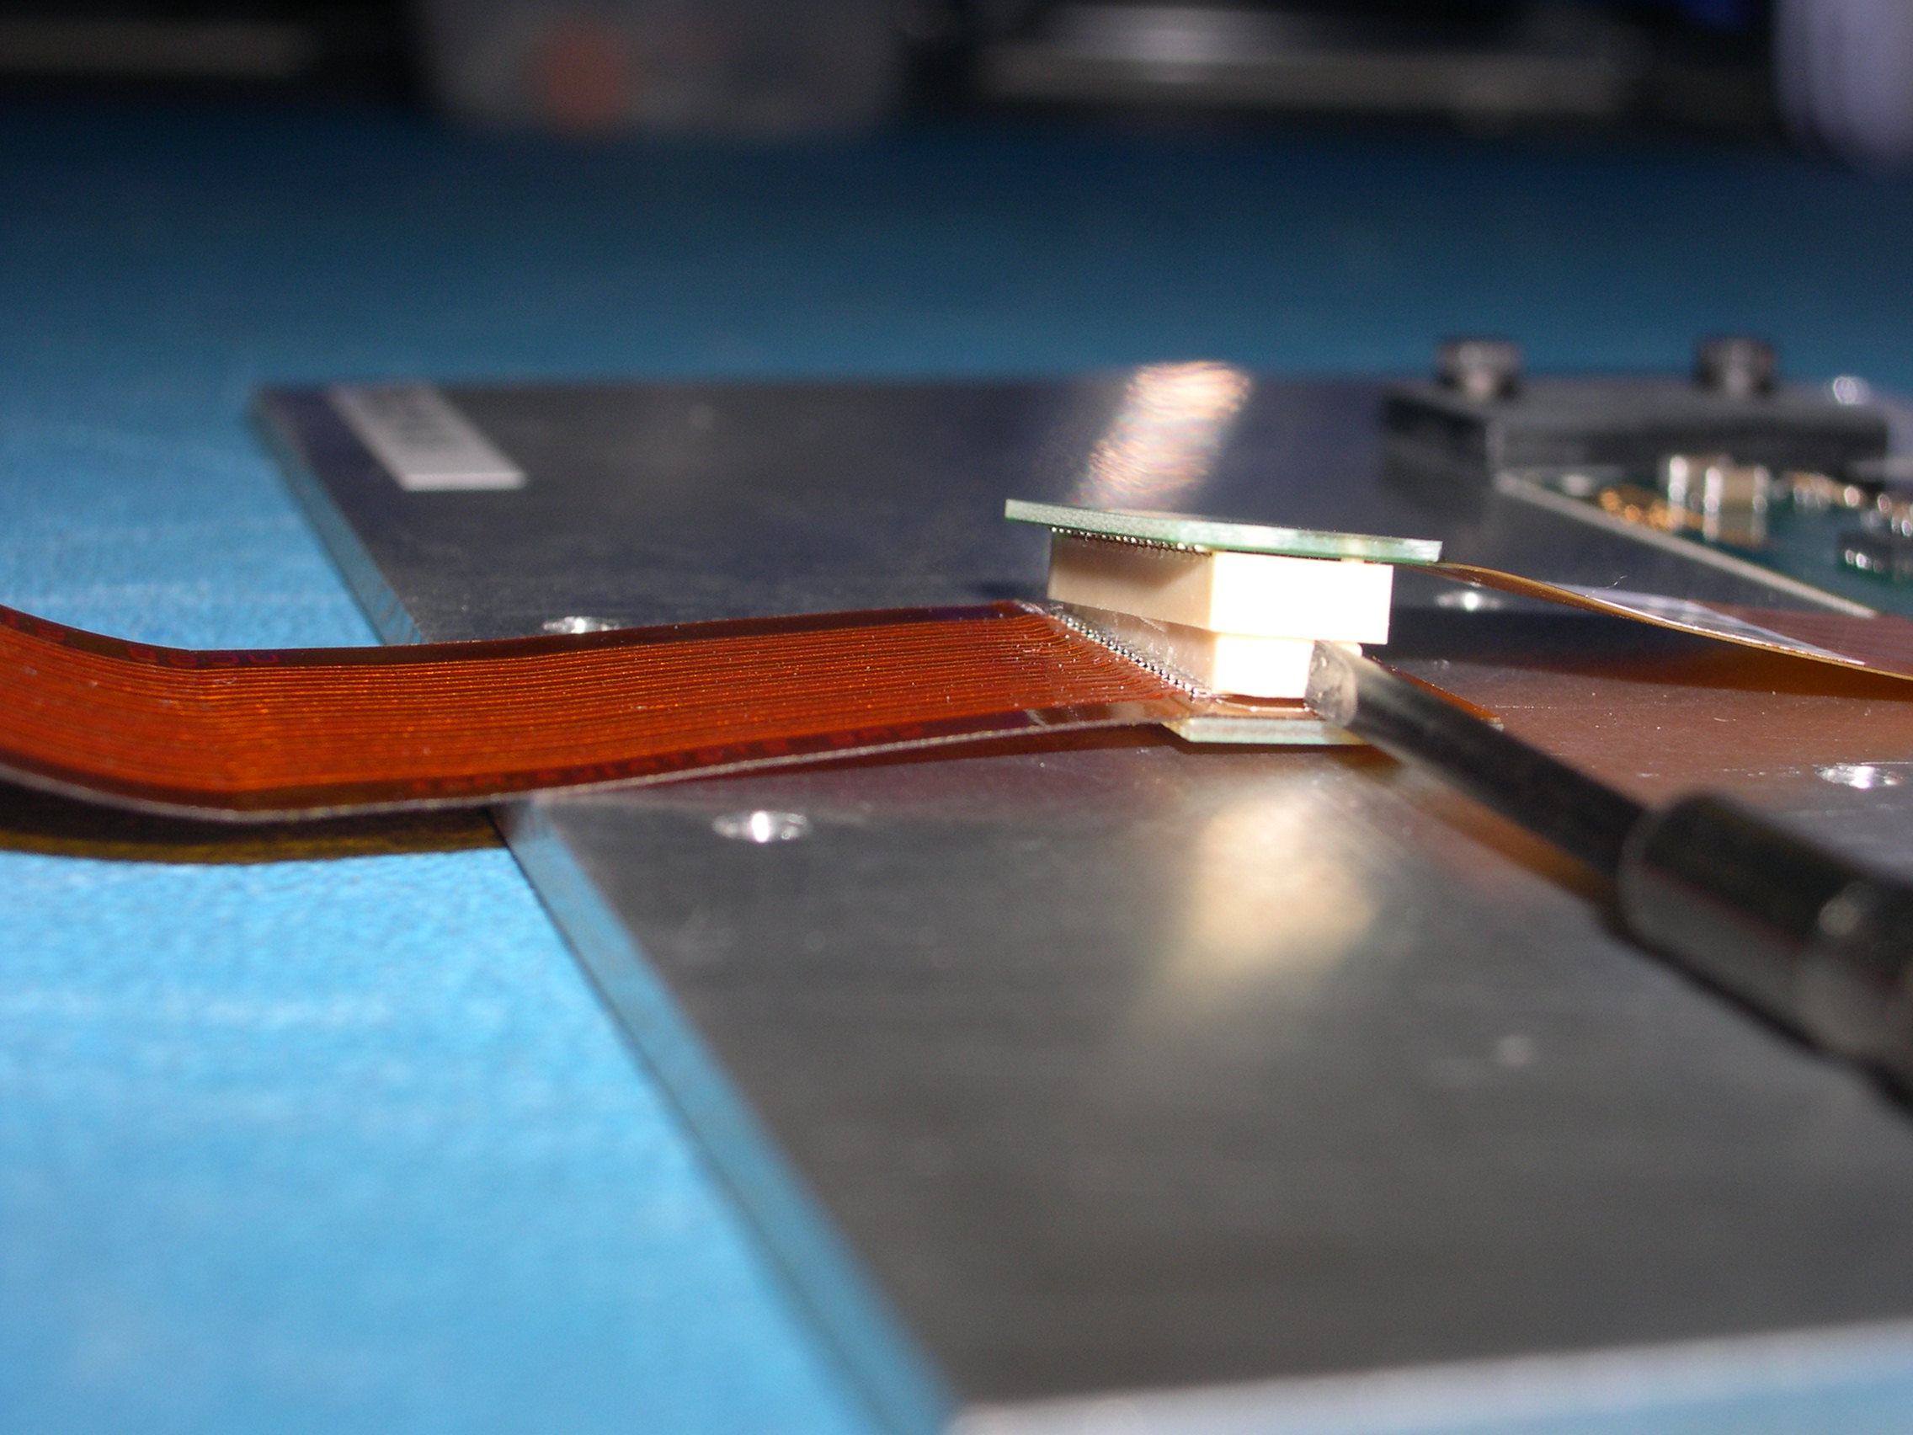

- Very gently push down on the SAME SIDE side of the connector
that was just freed in the upper right hand corner, this should release the
connector from the test tail.

- If the hybrid tail does not come completely free, gently grasp both ends and
gently wiggle it free. There should be very little to no resistance.

- Gently remove the hybrid tail from the test tail and remove test tail.

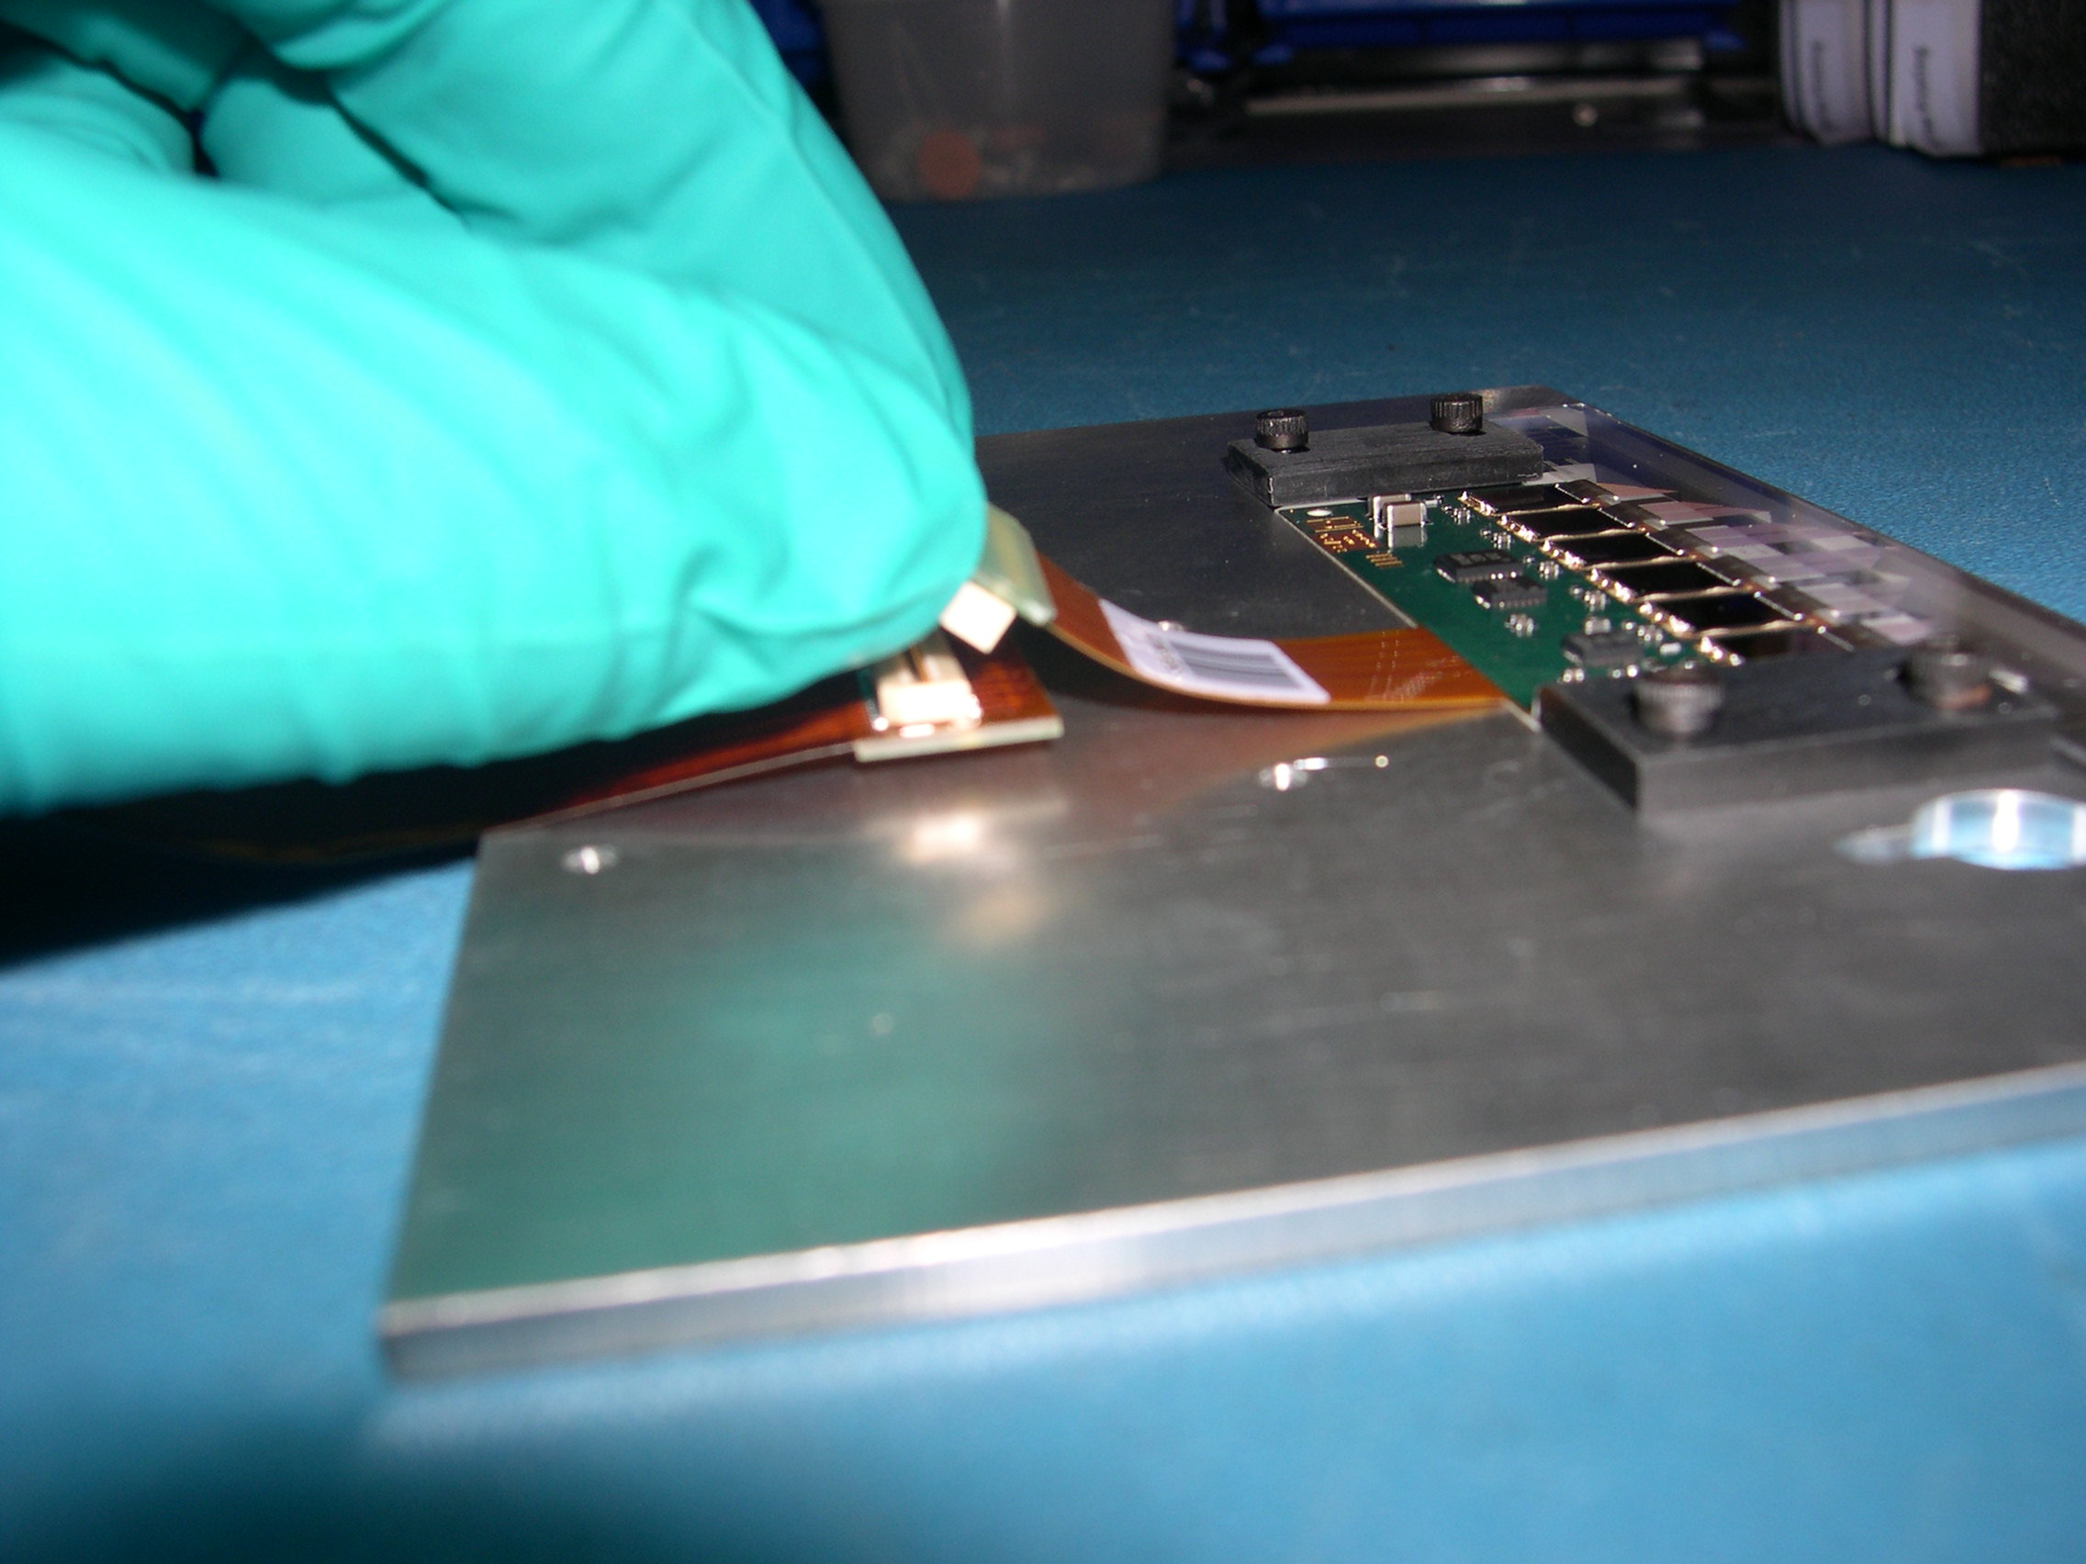

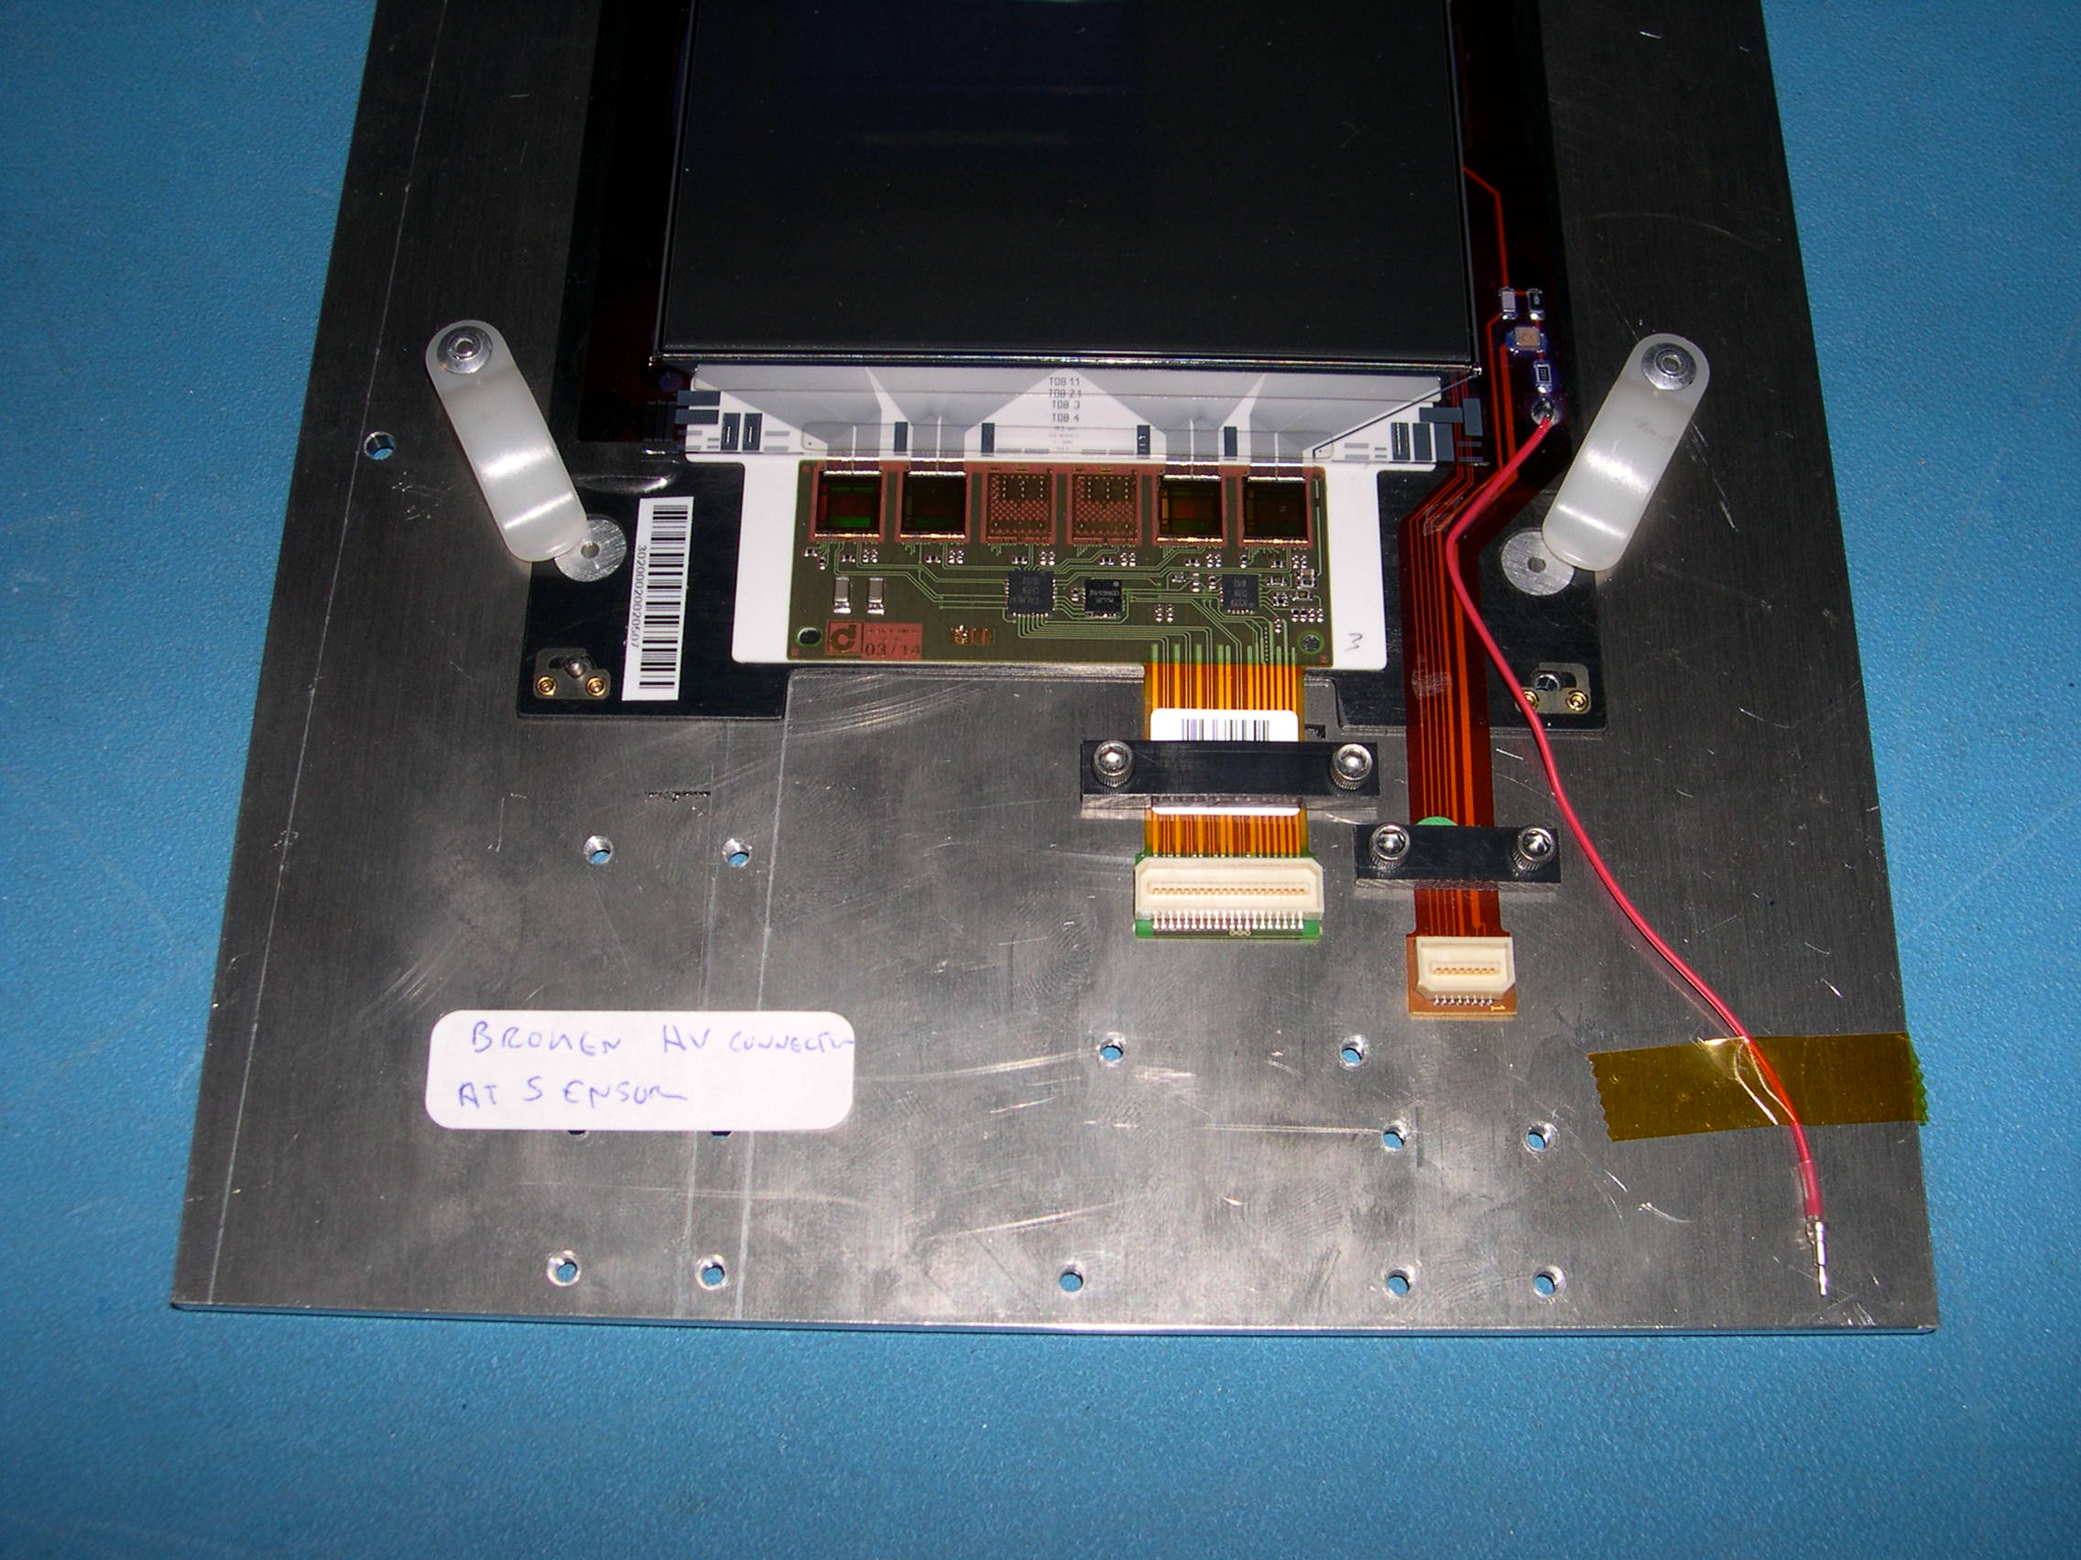
4) Carefully remove the upper high voltage clamp.

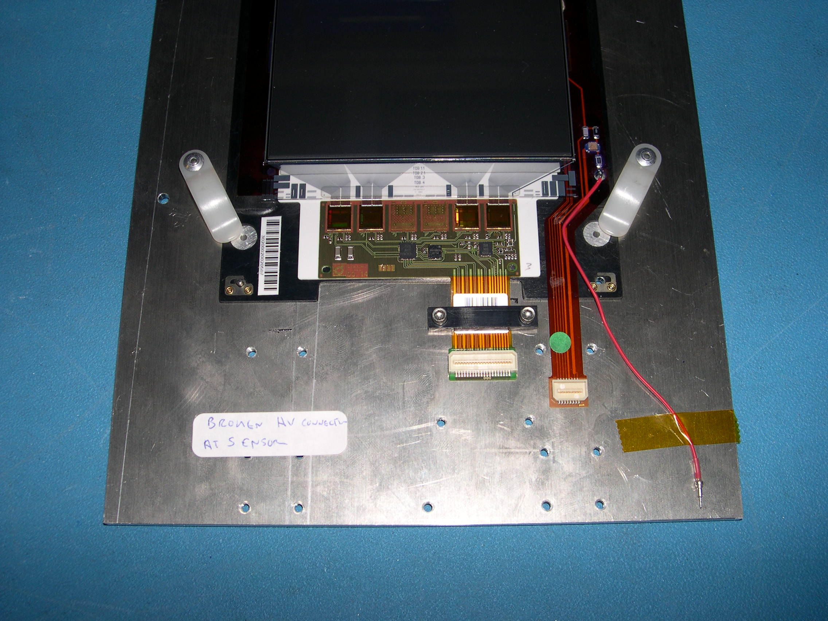

5) If the module has a hybrid with an 'Up' connector, carefully remove the upper
low voltage clamp.

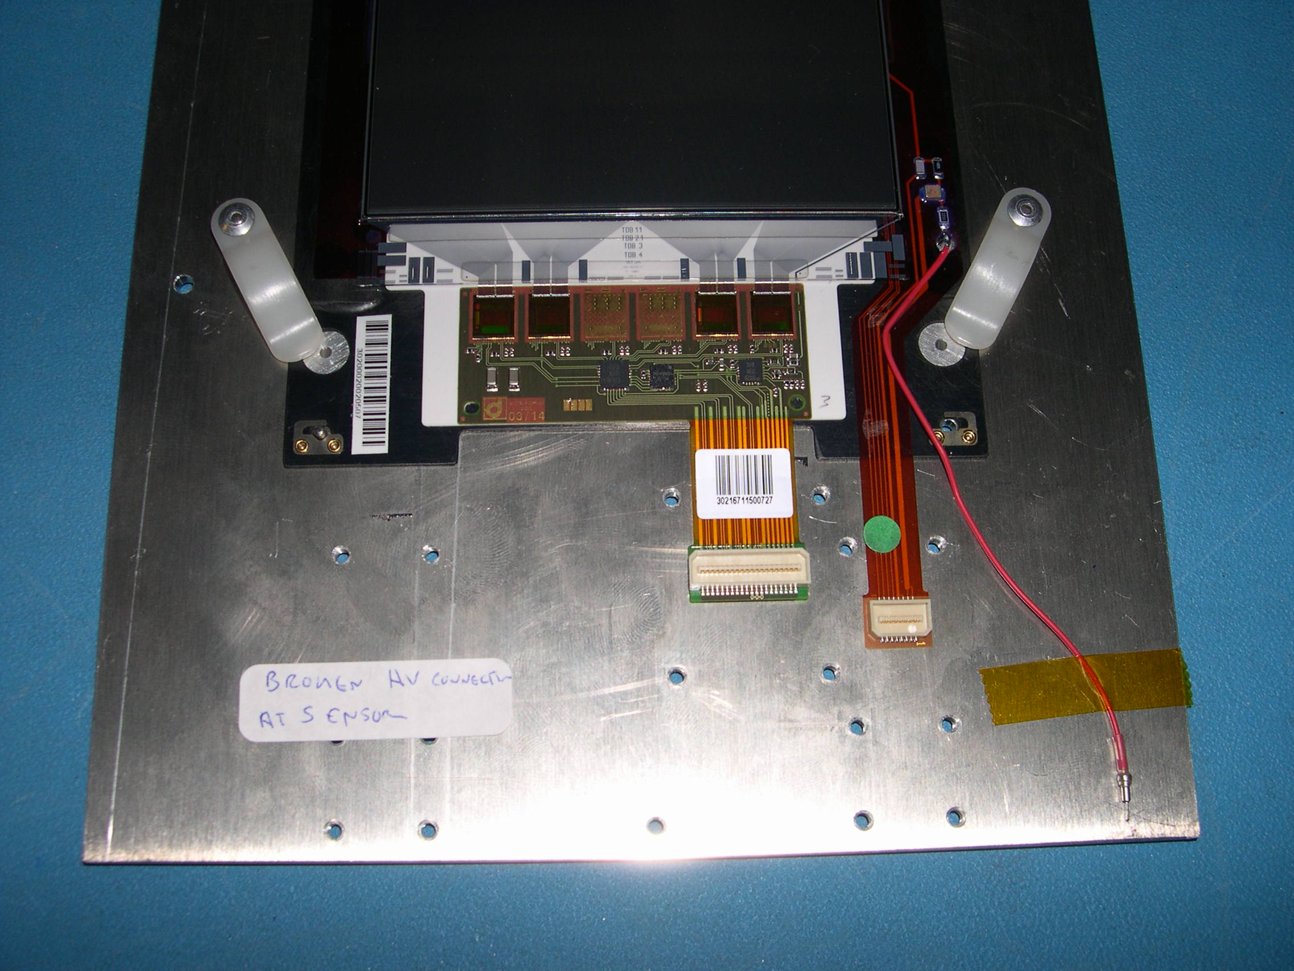

6) Properly store the module. TOB modules can be stored temporarily in the ‘LT
TESTING MODULES’ cabinet, but should be transferred as soon as possible to the
high bay for rod assembly.

