Hybrid Shipping Certification

• The following individuals can train others in the proper procedures for shipping hybrids:

Suzanne Kyre

• The following individuals have been trained in the hybrid handling procedures by someone authorized to do so in the list above.

Trainee | Trainer Authorization | Date

HYBRID SHIPPING PROCEDURES

Transfer the hybrids in the database:

Open the Big Browser database and access the Transfer workstation.
Click on “Add a New Card for Transfer.” Scan the transfer barcode label.
Enter the shipping information (destination, date, etc.).
Scan the barcodes for each hybrid being sent.
When finished, click “Update” on the toolbar and wait for the confirmation message.

Packaging the hybrids for shipping:

Find 2 sturdy cardboard boxes, one inside box and one outside box. The outside box should be larger than the other by at least two inches on all sides.
Measure the inside of the smaller box to determine how many hybrid boxes will fit in a single layer across the bottom of the box. See Figure 1.

Small Hybrid Boxes
Bottom of Smaller Shipping Box
Figure 1: Measuring the Shipping Box

In this example, the box will fit two rows of three hybrids each.
The hybrids must be sealed inside antistatic pouches. Take three hybrid boxes and place them in the roll of antistatic plastic along with a bag of desiccant. Seal the open end with the sealing iron, making at least three good seals. Cut the roll, leaving a few inches to seal the other side of the pouch. See Figure 2.

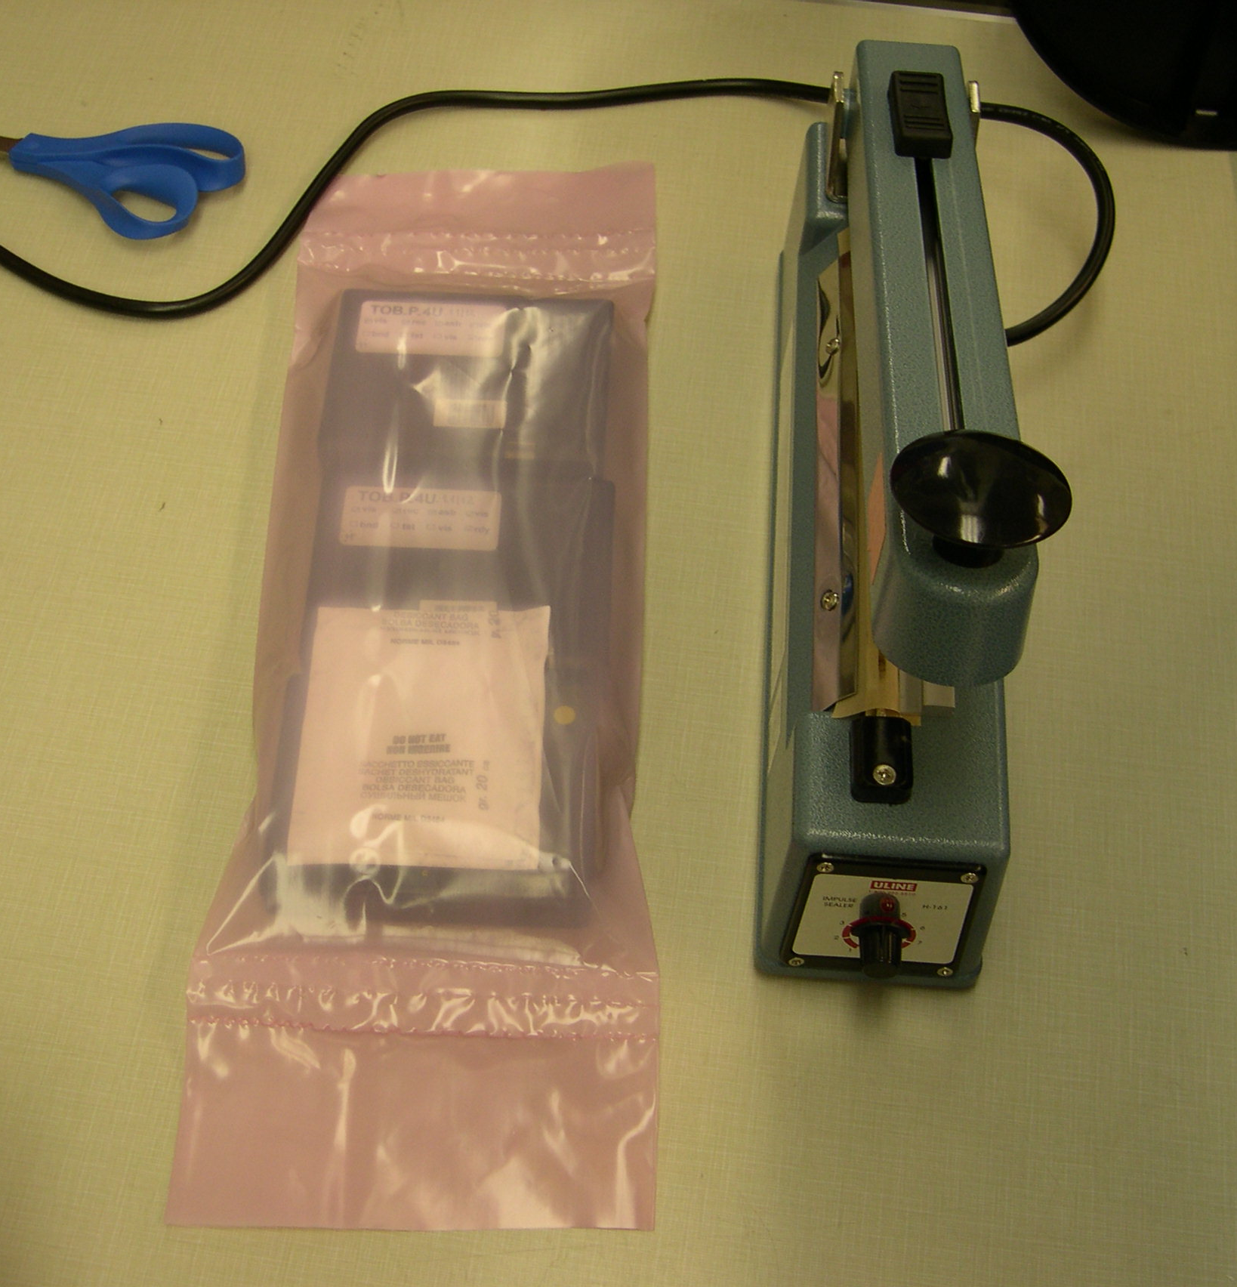
Sealing Iron
Desiccant Bag

Figure 2: Antistatic Pouch with Three Hybrids

Once all the hybrids have been sealed in antistatic pouches, wrap each pouch in bubble wrap and secure with tape. Make sure all the hybrids are kept right side up.
Place at least 1 inch of packing material (foam, bubble wrap, and/or peanuts) into the bottom of the smaller shipping box.
Place the pouches of hybrids into the box, careful to pack them all right side up. See Figure 3.

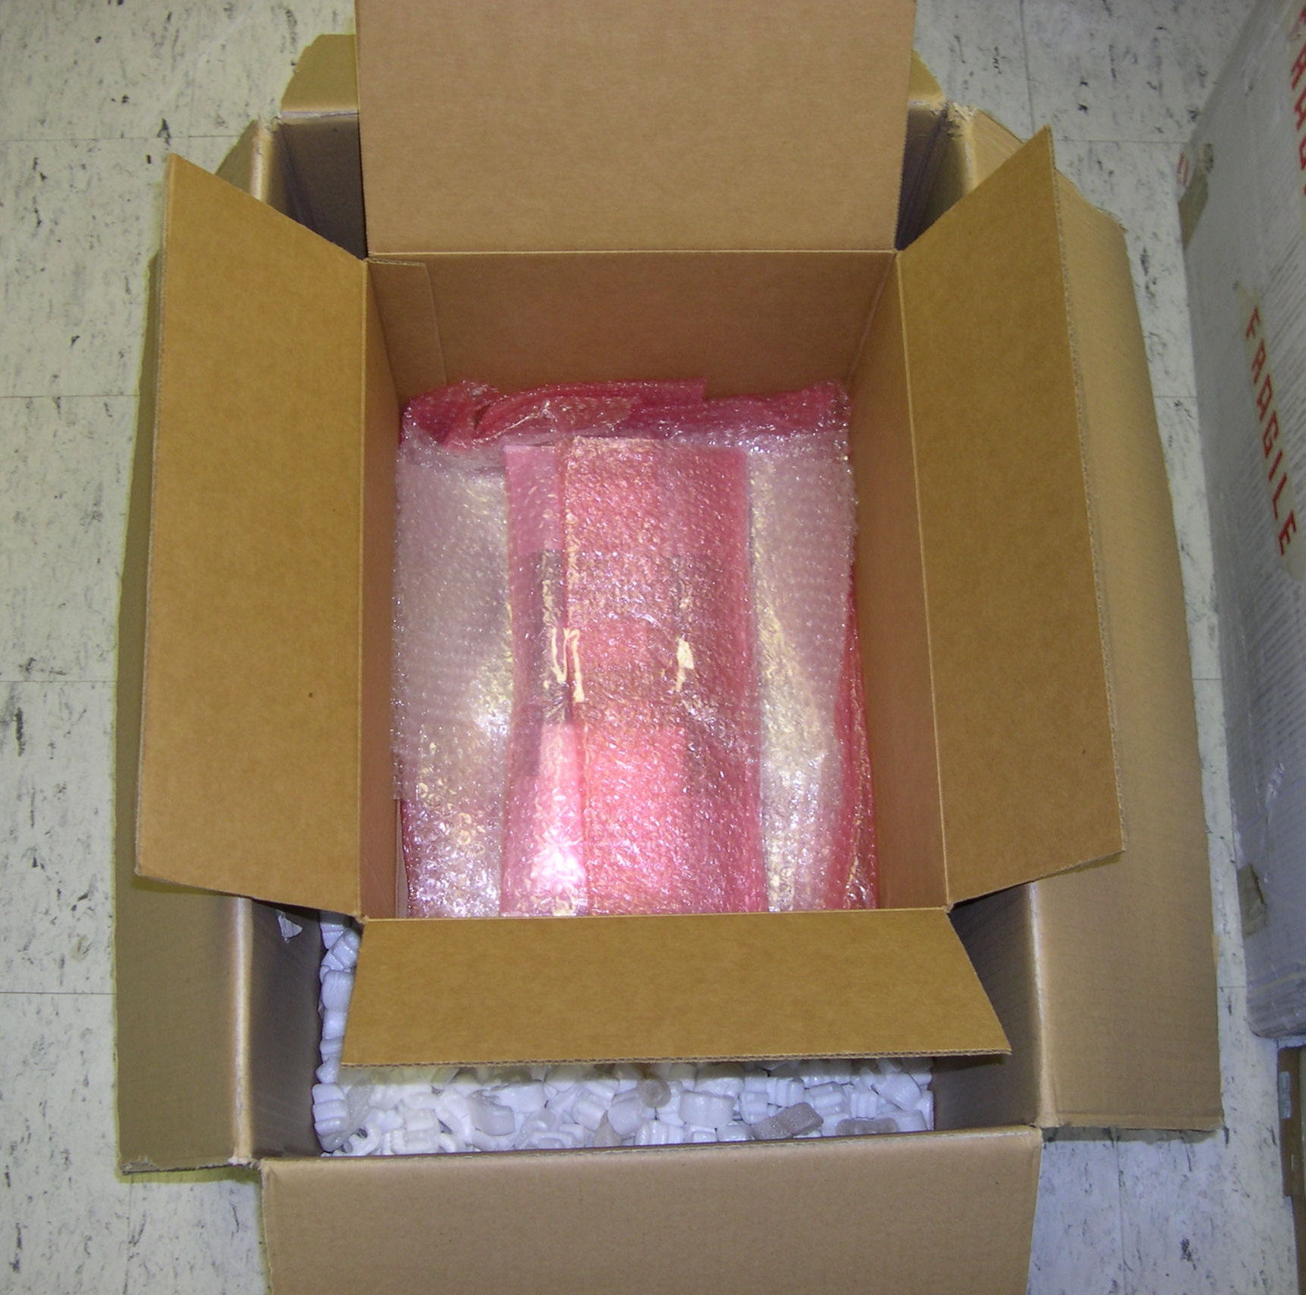
Antistatic pouch wrapped in bubble wrap
At least two inches of space on all sides of smaller box

Figure 3: Shipping Boxes
Cover the stack of hybrid pouches with more packing material until the carton is full. Tape closed. Attach the transfer barcode to the outside of the carton.
Fill the bottom of the larger carton with 2 inches of packing material. Place the smaller carton inside. Fill the sides and top of the large carton with packing material and tape closed.

Preparing the Pro Forma Invoice:

If the shipment will be sent out of the country, prepare a Pro Forma Invoice. A sample invoice is available on the website at:
http://hep.ucsb.edu/people/kyre/cms/sample-invoice.doc

Type the shipping address and contents of the package. The Harmonized Tariff code can be found here:
http://hep.ucsb.edu/cms/tariff-codes2.html

Measure the size and weight of each package and include this information at the bottom of the Pro Forma Invoice. Take 3 copies of the invoice and the package to the Physics Shipping/Receiving department. They will need to know the method of shipment and the account number for the bill.

