ARCS Test Stand Operation Certification

• The following individuals can train others in the proper procedures
for testing modules in the ARCS test stands.

Derek Barge, Ford Garberson

• The following individuals have been trained in the hybrid handling
procedures by someone authorized to do so in the list above.

Trainee | Trainer Authorization | Date

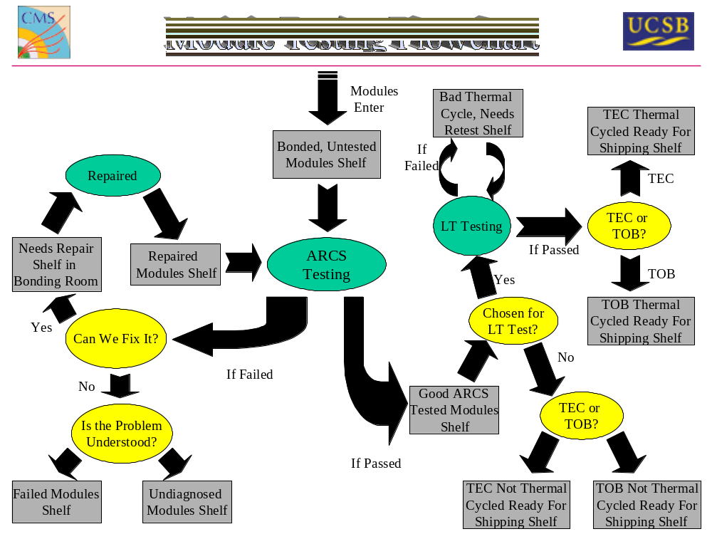

Note: If anything does not go according to this procedure, or you are
unsure about what you are doing, stop immediately and contact a supervisor. DO NOT continue to work until a supervisor is available.

Instructions for Use of Test Stands:
1) Preparation
a) Put on your foot grounding straps and check that they are functioning.
b) Clear the test stand area, and the hybrid testing table of clutter.
c) Remove the module you wish to test from the cabinet and set it on the hybrid testing table near the plastic bins with the clamps, screws and tails. Be careful not to touch the sensors or the hybrid electronics.
d) Clip on the high and low voltage tails, then screw in the black plastic stabilizing clamps. All the necessary supplies can be found in the bins, and Figure 1 shows the proper locations for TEC R5 and non-stereo TOB 1 and 2 modules. See the module tailing instructions for TEC modules and TOB modules for details.
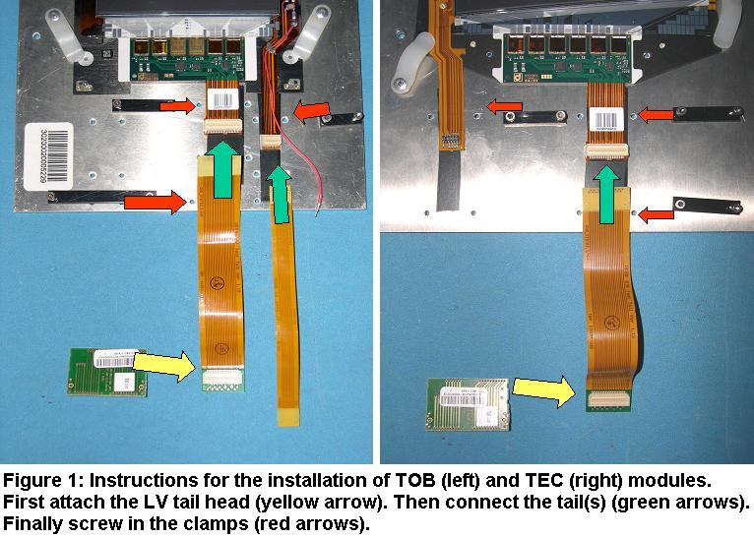

2) Set Up Module in Stand
a) Make sure you have the correct adapter card (TOB or TEC) plugged into the front-end card in the stand. The TOB HV tail can only connect to a TOB card.
b) The steel ribbon cable sticking out of the adapter card’s frame is the grounding cable. It will be on the bottom in TOB modules, and the top in TECs. Screw it securely into the stand.
c) Now put the module in place and connect the tails to the adapter card. If using a TOB module, also connect the small red high voltage wire. Wind it through the tails so that it cannot accidentally spring back and damage the silicon.
d) You can leave the stand open for now, but it's important to close it before you turn on the high voltage.
e) If you need them, more detailed instructions for step 2 are available.

3) Start ARCS
a) This step is only necessary when you start testing a different type of module, or when you wish to change the location in which ARCS saves its data. Go to the ARCS installation folder and open “ARCS_main_config.cfg”. On roughly the sixth line of text, enter the directory into which you want ARCS to save its output. On roughly line 12, enter the path name for the appropriate testsettings file - it should match the module type you are using. The files are physically located in the same directory as the ARCS program - (drive:\cms\ARCS_7.2_bugfix\). The picture and table below show the module types and the corresponding testsettings files. Note that two TEC R5's are shown, since these are different types of R5's (one with slanted sensors called a stereo, and one without), but both use the same cut files. The surest way to tell modules apart is by counting the number of chips they have, and consulting the table below.
Note: if you eventually want the output from the tests to be uploaded to the database, you can save time by setting the directory in which ARCS saves its files to be Z:\ . Each of the computers *should* have Z: mapped to /cms2/module/arcs_data/ , see step 9.

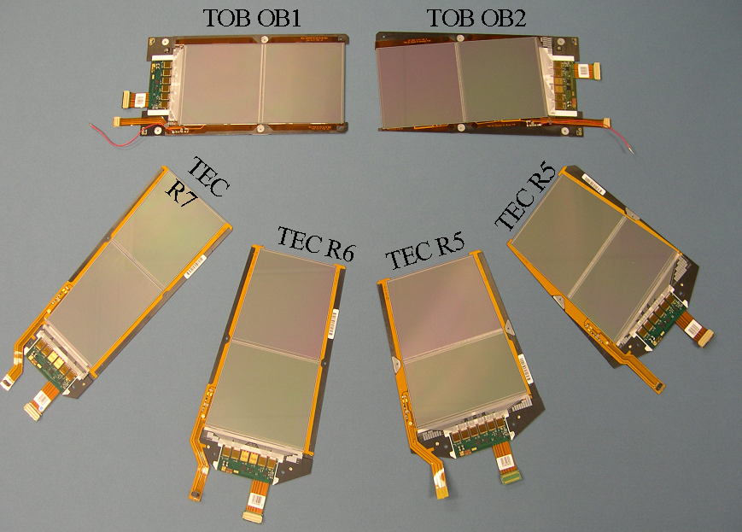

Table 1: Module type, chip number, and associated settings file
Module Type | # of chips | Testsettings file
OB 1 | 6 | TOB_OB1_testsettings_1.0.xml
OB 2 | 4 | TOB_OB2_testsettings_1.0.xml
TEC Ring 5 | 6 | TEC_R5_testsettings_1.0.xml
TEC Ring 6 | 4 | TEC_R6_testsettings_1.0.xml
TEC Ring 7 | 4 | TEC_R7_testsettings_1.0.xml

b) Turn on the low voltage power supplies.
c) Open ARCS. If you receive a message asking you to select the appropriate dll file, pick “arcs_dll.dll”, though this bug should be fixed by now. When the window with the toaster picture shows up, click “Start ARCS”.
-If you get lots of error messages about boards failing to initialize, you probably forgot to turn on the low voltage power supplies. You'll have to restart the program.
d) After ARCS has finished loading, you will be prompted with two fields in which you are asked to fill in identifications for “hybrid 1” and “hybrid 2”. If you are testing modules during an actual production, input the exact 14 digit id number of the module, otherwise you can call it whatever you want. Since the stand should be plugged into the "hybrid 1" slot of the ARC board, this id number should go in the "HYBRID 1" field. Click “Set IDs”, and Close the stand.

4) Run Tests
Note: Make sure the stand is closed before you run these tests. Even if you forgot to turn on the high voltage before, many of these tests turn the high voltage on automatically.
a) Click the “All Tests” tab, and select the tests you want to run. During production, click "Select all Tests", and it will automatically select the appropriate tests to run. You can verify that the correct tests are selected:
-Measure IV Curve
-Fast Test (Chip Functionality …)
-Pedestal, Noise, Common Mode, Deconvolution Mode, Inverter OFF
-" " Deconvolution Mode, Inverter ON
-" " Peak Mode, Inverter OFF
-" " Peak Mode, Inverter ON
-Pulse Shape, Deconvolution Mode, Inverter OFF
-" " Deconvolution Mode, Inverter ON
-" " Peak Mode, Inverter OFF
-" " Peak Mode, Inverter ON
-Pipeline, Peak Mode, Inverter ON only
-Pinhole Test
b) click the “Start All Tests” button. A window will pop up displaying the testsettings file that will be used – verify that it matches the one you specified in 3a and agree to it. If you picked the wrong file in 3a, you’ll have to close ARCS, make the fix, and restart. Details on the specific tests are provided at the end of this procedure.
c) Upon completion of the tests, the program will return to the All Tests page and list the faulty channels and causes on the right side of the page. Click on the deep tests tab and look through the tests ARCS has run and make sure that the faulty channels list is correct. If you need help with fault diagnosis, have a look at some general guidelines.
d) If you now want to run a new set of tests that save to different files or have a different testsettings input, then you’ll have to close ARCS and update your settings before you restart it.

6) Fill out checklist
(Do this step if you're testing a module for the first time, or if you're retesting the module after repairs, or if you're retesting a module that passed a previous test but now has unexpected results).
a) Open up the CMS Database webpage, http://hep.ucsb.edu/people/dbarge/ucsb_cms_database.html . Click the link to "New Module Checklist". After everything has loaded, you will be asked to fill out the faulty channels for the module.
b) Here I will outline the procedure for deciding whether faults are expected or unexpected. There will be three sources of information you will use: the output of faults and likely faults from ARCS, the "Hybrid Data" in the checklist, and the "Sensor Data" in the checklist. An example is shown in Figure ___ below.
Note: The faulty channels flagged by ARCS often require some user interpretation. Opens are sometimes flagged with conflicting location results, or as only "likely" opens. It will be up to the user to decide whether these are one sensor or two sensor opens, or whether they're even real. Further, ARCS occasionally outputs faulty channels with flags such as "faulty for unknown reason". Guidelines for diagnosing faults are given in the descriptions of the individual tests below. You may also need to look at the module under a microscope to see if you can find an obvious source for certain unusual errors. If you ever aren't sure what fault to list for a channel, ask a more experienced user.
Procedures:
One and Two Sensor Opens: it should be listed as "expected" if
-It is a two sensor open, and it is listed under "Hybrid Opens" in Hybrid Data, or
-It is listed under "Missing or Pulled Bonds" under "Sensor Data" as the correct type of open. Obviously, "Near Sensor" missing bonds result in two sensor opens, and "Far Sensor" missing bonds result in one sensor opens.
-Otherwise the open is "unexpected"
-The checklist will load with a prediction of the expected opens. If these are incorrect, change them.
Mid Sensor Opens: Should be "expected" if
-The channel is listed under "ISTRIP" for the correct sensor. (look under a microscope to determine which sensor is the correct one)
-The channel is listed under "CAC" for the correct sensor.
-Otherwise the mid sensor open is "unexpected". To date, every mid sensor open has been "unexpected".
Pinholes: Should be "expected" if
-The channel appears under both "CAC" and "IDIEL" for the correct sensor. Determine which sensor is correct by using a microscope.
-Otherwise, the pinhole is "unexpected".
Shorts: Should be "expected" if
-All shorted channels are listed as "CAC"s under the correct sensor.
-Otherwise, shorts are "unexpected".
Noisy: Should be "expected" if
-It is listed under "ISTRIP", or if it is part of a group of channels that come up noisy, clustered around a channel that is listed under "ISTRIP".
-Otherwise, the noisy channel is "unexpected".
c) Input the faulty channel information into the checklist.
Note: Every channel number entered must be three digits. For example, if channel three is a two sensor open, it should be entered as "003", as shown in the image below.
Note also: Multiple channels must be separated by spaces, not commas.
Note also also: Every field must be filled in. If there are no unexpected mid sensor opens, for example, type "null" into the appropriate field.
If you don't follow the proper formatting procedures for filling out the checklist, you will be unable to submit it.
d) Now you have to decide whether the module should pass or fail. The module should fail if:
-There are any shorts or pinholes.
-There are any unexpected one or two sensor opens that have not yet been cleared with the bonding people.
-ARCS gives the module a grade of "C" (ARCS grades every module in the same window as it lists all the faults). A grade of C tells you that at least 2% of the module channels are faulty.
There is some other major unusual problem, for example if
-There is a common mode noise problem. A channel has a common mode noise problem if it has a high enough noise to raise the raw noise in the rest of the chip significantly above the common mode subtracted noise, as seen in the noise display. This problem will also show up in the monitoring screen while you're at 400V. If there is a common mode noise problem, you'll see the output of the faulty channel flash rapidly up and down, vastly more than it does for the channels around it.
-There is a via open. This problem is unusual and not immediately obvious. If the via is open for a particular chip, then the pedestal will gradually begin to drift. This will manifest itself in a number of bizarre effects in the tests you run, but the easiest way to diagnose the problem is to return to the monitoring page. After the high voltage is first turned on, the output of the faulty chip on the monitoring page will gradually drift upwards away from the other chips until it saturates, at which point it will drop all the way to zero. Running the pinhole test will vastly accelerate this process.
-There is any other error that you don't understand. See the ARCS error catalog for more information on problems and possible solutions. If you do fail the module, explain why in the comments section.
e) Submit the checklist.
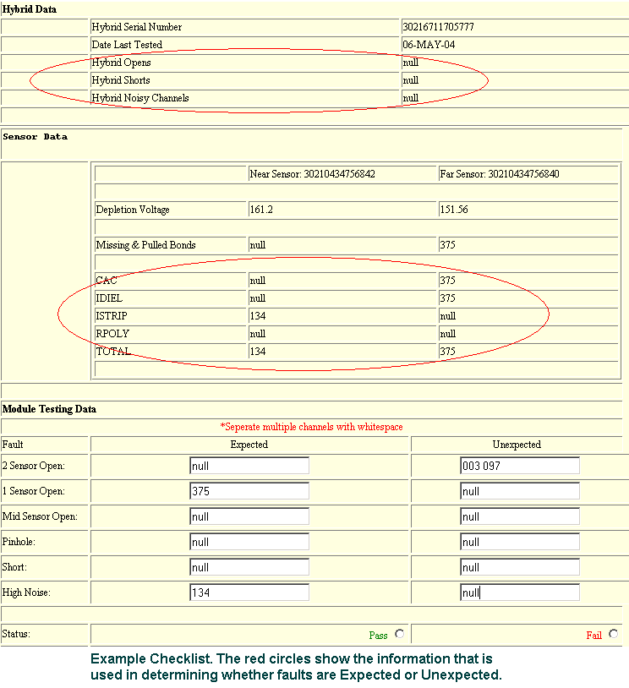
7) Shutting everything down when you’re done
NOTE: If you have any uncertainties about the use of the high voltage control program, ask a more experienced user for help. Improper use of this program could damage or destroy the module
a) Open the HV controller program. To do this, click the gray "Monitoring" Tab. Then click the blue "Additional Controller" tab. Now click the "High Voltage" button and the high voltage control program will appear. Be sure to do the next two steps in order.
b) On the upper left side of the control window is the voltage control interface. The blue number is the target voltage, and the green number is the actual voltage that the module is currently biased at (both numbers should initially be set at 400V). You want shut down the high voltage safely, so change the blue number to zero and wait while the green number drops to zero as well, at a safe speed.
c) After the actual (green) voltage has reached zero, toggle the HV switch to off. The control panel should gray out. It is now safe to shut down ARCS.
d) Turn off the low voltage power supplies. It is now safe to open the stand, unplug the module and remove it.
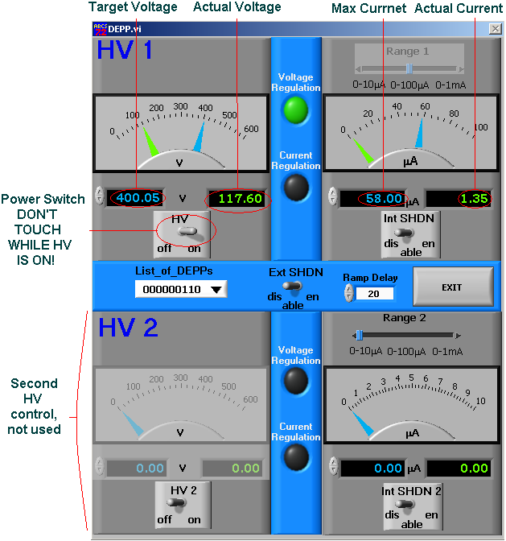

8) Reshelve the Module
a) If the module passed the tests, then it should be stored on the "Good ARCS tested modules shelf" in the "LT Testing Modules" cabinet.
b) If the module failed because of shorts or pinholes, then it can be repaired. Label the module with a repair sticker listing the problem and the channel numbers. Now place the module in a plastic transport case and put it on the "Needs Repair" shelf of the wirebonding cabinet.
c) If the module failed, you understand the problem, and you know that no repair is possible, it should be stored on the "Failed Modules" shelf in the "ARCS Testing Modules" cabinet.
d) If the module failed and you don't understand the problem, it should be stored on the "Failed undiagnosed modules" shelf of the "ARCS Testing Modules" cabinet.

9) Uploading .root and .xml files
a) If the files aren’t there already (from step 3a), copy both the root and the xml files to \\cms2\module\arcs_data\ .
-If for some reason this directory is not already mapped to drive z: , then you can get to it by opening My Computer. Click "Tools", and select "Map Network Drive". Pick a drive letter name, and for Folder set \\hadron.physics.ucsb.edu\cms2\module\arcs_data\ . Click "connect using a different user name" and input your username in the window that appears but leave your password blank. Now click Finish and enter your password. The directory should now be mapped.
b) The xml files will be automatically uploaded to the database overnight. If there are any errors in this process, Derek will be notified by automatic e-mail.

